FULL STACK DEVELOPMENT LAB EXERCISE -3

NAME: VISMITAA S
REGISTER NUMBER:2648552

- SOURCE CODE

<!DOCTYPE html>
<html lang="en" class="scroll-smooth">
<head>
<meta charset="UTF-8">
<meta name="viewport" content="width=device-width, initial-scale=1.0">
<title>CreatorIQ — AI-Powered Pre-Upload YouTube Analytics</title>

<!-- Google Fonts: Plus Jakarta Sans -->
<link rel="preconnect" href="https://fonts.googleapis.com">
<link rel="preconnect" href="https://fonts.gstatic.com" crossorigin>
<link href="https://fonts.googleapis.com/css2?family=Plus+Jakarta+Sans:wght@300;400;500;600;700;800&display=swap" rel="stylesheet">

<!-- Tailwind CSS CDN -->
<script src="https://cdn.tailwindcss.com"></script>

<!-- Custom Styles & Clean Keyframe Animations -->
<style>
body {
font-family: 'Plus Jakarta Sans', sans-serif;
}

/* Subtle grid background pattern */
.bg-grid-pattern {
background-size: 40px 40px;
background-image:
linear-gradient(to right, rgba(255, 255, 255, 0.03) 1px, transparent 1px),
linear-gradient(to bottom, rgba(255, 255, 255, 0.03) 1px, transparent 1px);
}

/* Gentle floating animations */
@keyframes float {
0%, 100% { transform: translateY(0px); }
50% { transform: translateY(-10px); }
}

.animate-float {
animation: float 5s ease-in-out infinite;
}

.animate-float-delayed {
animation: float 6s ease-in-out 1s infinite;
}
</style>
</head>

<body class="bg-black text-zinc-100 antialiased selection:bg-red-600 selection:text-white min-h-screen relative overflow-x-hidden">

<!-- Ambient Red Glow Background Effects -->
<div class="fixed inset-0 pointer-events-none z-0 overflow-hidden">
<div class="absolute -top-32 left-1/2 -translate-x-1/2 w-[600px] h-[450px] bg-red-600 rounded-full blur-[140px] opacity-20"></div>
<div class="absolute top-[40%] -right-32 w-[500px] h-[500px] bg-red-700 rounded-full blur-[150px] opacity-15"></div>
<div class="absolute bottom-20 -left-32 w-[500px] h-[500px] bg-red-600 rounded-full blur-[140px] opacity-15"></div>
</div>

<!-- Background Grid Pattern -->
<div class="fixed inset-0 bg-grid-pattern opacity-60 pointer-events-none z-0"></div>

<!-- ================================================================= -->
<!-- 1. NAVBAR (Sticky Glassmorphic Header) -->
<!-- ================================================================= -->
<header class="sticky top-0 z-50 w-full border-b border-zinc-800/80 bg-black/80 backdrop-blur-xl transition-all">
<div class="max-w-7xl mx-auto px-4 sm:px-6 lg:px-8">
<div class="flex items-center justify-between h-20">

<!-- Logo & Brand Name -->
<a href="#" id="brand-logo-link" class="flex items-center gap-3 group cursor-pointer">
<div class="w-10 h-10 rounded-xl bg-gradient-to-tr from-red-600 to-rose-500 flex items-center justify-center shadow-lg shadow-red-600/30 group-hover:scale-105 transition-all">
<svg class="w-5 h-5 text-white fill-current" viewBox="0 0 24 24">
<path d="M8 5v14l11-7z"/>
</svg>
</div>
<div class="flex flex-col">
<span class="text-xl font-extrabold tracking-tight text-white flex items-center gap-1">
Creator<span class="text-transparent bg-clip-text bg-gradient-to-r from-red-500 to-rose-400">IQ</span>
</span>
<span class="text-[10px] tracking-widest uppercase text-zinc-400 font-semibold -mt-1">Pre-Upload AI</span>
</div>
</a>

<!-- Desktop Navigation Links -->
<nav class="hidden md:flex items-center space-x-2">
<a href="#features" class="nav-landing-link px-4 py-2 text-sm font-medium text-zinc-300 hover:text-white hover:bg-zinc-900/60 rounded-lg transition-colors">Features</a>
<a href="#how-it-works" class="nav-landing-link px-4 py-2 text-sm font-medium text-zinc-300 hover:text-white hover:bg-zinc-900/60 rounded-lg transition-colors">How It Works</a>
<a href="#about" class="nav-landing-link px-4 py-2 text-sm font-medium text-zinc-300 hover:text-white hover:bg-zinc-900/60 rounded-lg transition-colors">About</a>
</nav>

<!-- Desktop CTA Button -->
<div class="hidden md:flex items-center gap-4">
<a href="#home" id="btn-nav-get-started" class="btn-get-started-trigger inline-flex items-center gap-2 px-6 py-2.5 rounded-xl font-semibold text-sm text-white bg-gradient-to-r from-red-600 to-rose-600 hover:from-red-500 hover:to-rose-500 shadow-lg shadow-red-600/25 hover:scale-[1.02] transition-all cursor-pointer">
<span>GET STARTED</span>
<svg class="w-4 h-4" fill="none" stroke="currentColor" viewBox="0 0 24 24">
<path stroke-linecap="round" stroke-linejoin="round" stroke-width="2" d="M14 5l7 7m0 0l-7 7m7-7H3"/>
</svg>
</a>
</div>

<!-- Pure CSS Mobile Menu Toggle -->
<input type="checkbox" id="nav-toggle" class="hidden peer">
<label for="nav-toggle" class="md:hidden p-2.5 rounded-xl text-zinc-400 hover:text-white hover:bg-zinc-900 border border-zinc-800 cursor-pointer select-none">
<svg class="w-6 h-6" fill="none" stroke="currentColor" viewBox="0 0 24 24">
<path stroke-linecap="round" stroke-linejoin="round" stroke-width="2" d="M4 6h16M4 12h16M4 18h16"/>
</svg>
</label>

<!-- Mobile Dropdown Drawer -->
<div class="peer-checked:flex hidden flex-col absolute top-20 left-0 w-full bg-zinc-950/95 backdrop-blur-2xl border-b border-zinc-800 p-6 space-y-4 md:hidden shadow-2xl z-50">
<a href="#features" class="nav-landing-link text-zinc-300 hover:text-white text-base font-medium py-2 border-b border-zinc-900">Features</a>
<a href="#how-it-works" class="nav-landing-link text-zinc-300 hover:text-white text-base font-medium py-2 border-b border-zinc-900">How It Works</a>
<a href="#about" class="nav-landing-link text-zinc-300 hover:text-white text-base font-medium py-2 border-b border-zinc-900">About</a>
<a href="#home" id="btn-mobile-get-started" class="btn-get-started-trigger flex items-center justify-center gap-2 w-full py-3 rounded-xl font-semibold text-white bg-red-600 hover:bg-red-500 shadow-lg shadow-red-600/30 cursor-pointer">
<span>GET STARTED</span>
<svg class="w-4 h-4" fill="none" stroke="currentColor" viewBox="0 0 24 24">
<path stroke-linecap="round" stroke-linejoin="round" stroke-width="2" d="M14 5l7 7m0 0l-7 7m7-7H3"/>
</svg>
</a>
</div>

</div>
</div>
</header>

<!-- ================================================================= -->
<!-- LANDING PAGE VIEW (Hero, Features, How It Works, About) -->
<!-- Smooth 500-800ms transition to Home/Upload Page on "Get Started" -->
<!-- ================================================================= -->
<div id="landing-page-view" class="transition-all duration-500 ease-out">

<!-- ================================================================= -->
<!-- 2. HERO SECTION -->
<!-- ================================================================= -->
<section class="relative z-10 pt-12 pb-20 md:pt-20 md:pb-32 overflow-hidden">
<div class="max-w-7xl mx-auto px-4 sm:px-6 lg:px-8">
<div class="grid grid-cols-1 lg:grid-cols-12 gap-12 lg:gap-8 items-center">

<!-- Left Column: Copy & Actions -->
<div class="lg:col-span-6 space-y-8 text-center lg:text-left">

<!-- Red Badge -->
<div class="inline-flex items-center gap-2 px-3.5 py-1.5 rounded-full bg-red-950/60 border border-red-800/60 text-red-400 text-xs font-semibold tracking-wider uppercase">
<span class="w-2 h-2 rounded-full bg-red-500 animate-ping"></span>
<span>AI-POWERED YOUTUBE ANALYTICS</span>
</div>

<!-- Heading -->
<h1 class="text-4xl sm:text-5xl lg:text-6xl font-extrabold tracking-tight text-white leading-tight">
Make Every <br class="hidden sm:block">
<span class="text-transparent bg-clip-text bg-gradient-to-r from-white via-zinc-200 to-zinc-400">
Upload Count.
</span>
</h1>

<!-- Subtitle -->
<p class="text-base sm:text-lg text-zinc-400 max-w-xl mx-auto lg:mx-0 leading-relaxed">
Analyze your video before publishing. Discover its quality, engagement potential, and what you can improve before it goes live.
</p>

<!-- CTAs -->
<div class="pt-2 flex flex-col sm:flex-row items-center justify-center lg:justify-start gap-4">
<a href="#home" id="btn-get-started" class="btn-get-started-trigger w-full sm:w-auto inline-flex items-center justify-center gap-3 px-8 py-4 rounded-xl font-bold text-base text-white bg-gradient-to-r from-red-600 to-rose-600 hover:from-red-500 hover:to-rose-500 shadow-xl shadow-red-600/30 hover:scale-[1.02] transition-all cursor-pointer">
<span>Get Started →</span>
</a>
<a href="#features" class="w-full sm:w-auto inline-flex items-center justify-center px-6 py-4 rounded-xl font-medium text-sm text-zinc-300 hover:text-white bg-zinc-900/60 hover:bg-zinc-800 border border-zinc-800 transition-all">
Explore Features
</a>
</div>

<!-- Tagline -->
<div class="pt-2 flex items-center justify-center lg:justify-start gap-3 text-xs tracking-widest uppercase font-medium text-zinc-400">
<span class="text-red-400">Analyze</span>
<span class="text-zinc-600">•</span>
<span class="text-zinc-200">Improve</span>
<span class="text-zinc-600">•</span>
<span class="text-red-400">Upload</span>
</div>

<!-- Trust Stats Bar -->
<div class="pt-6 border-t border-zinc-900 grid grid-cols-3 gap-4 max-w-md mx-auto lg:mx-0 text-left">
<div>
<div class="text-xl font-bold text-white">99.4%</div>
<div class="text-[11px] text-zinc-400">Accuracy Rate</div>
</div>
<div>
<div class="text-xl font-bold text-white">&lt; 30s</div>
<div class="text-[11px] text-zinc-400">Full Analysis</div>
</div>
<div>
<div class="text-xl font-bold text-white">4K 60fps</div>
<div class="text-[11px] text-zinc-400">HDR Support</div>
</div>
</div>
</div>

<!-- Right Column: Interactive Dashboard Mockup -->
<div class="lg:col-span-6 relative flex items-center justify-center py-6">

<!-- Ambient Glow -->
<div class="absolute inset-0 bg-red-600/20 blur-3xl rounded-3xl pointer-events-none"></div>

<!-- Main Floating Dashboard Card -->
<div class="relative w-full max-w-lg bg-zinc-950/90 backdrop-blur-2xl border border-zinc-800 rounded-2xl p-6 sm:p-7 shadow-2xl animate-float hover:border-red-500/40 transition-colors">

<!-- Header -->
<div class="flex items-center justify-between pb-5 border-b border-zinc-800">
<div class="flex items-center gap-3">
<div class="w-8 h-8 rounded-lg bg-red-600/20 border border-red-500/30 flex items-center justify-center text-red-500">
<svg class="w-4 h-4" fill="none" stroke="currentColor" viewBox="0 0 24 24">
<path stroke-linecap="round" stroke-linejoin="round" stroke-width="2" d="M15 10l4.553-2.276A1 1 0 0121 8.618v6.764a1 1 0 01-1.447.894L15 14M5 18h8a2 2 0 002-2V8a2 2 0 00-2-2H5a2 2 0 00-2 2v8a2 2 0 002 2z"/>
</svg>
</div>
<div>
<div class="text-xs font-bold uppercase tracking-wider text-red-500">CreatorIQ Engine</div>
<div class="text-sm font-semibold text-white">Video Analysis</div>
</div>
</div>
<div class="inline-flex items-center gap-1.5 px-2.5 py-1 rounded-full bg-emerald-950/50 border border-emerald-700/40 text-[11px] font-medium text-emerald-400">
<span class="w-1.5 h-1.5 rounded-full bg-emerald-400"></span>
Scanned
</div>
</div>

<!-- Score Progress -->
<div class="mt-6 p-4 rounded-xl bg-zinc-900/60 border border-zinc-800">
<div class="flex items-baseline justify-between mb-2">
<span class="text-xs font-bold tracking-wider uppercase text-zinc-400">VIDEO QUALITY</span>
<div class="flex items-baseline gap-1">
<span class="text-3xl font-extrabold text-white">87</span>
<span class="text-sm font-semibold text-zinc-400">/ 100</span>
</div>
</div>
<div class="w-full bg-zinc-800 rounded-full h-2.5 overflow-hidden">
<div class="bg-gradient-to-r from-red-600 to-rose-500 h-2.5 rounded-full w-[87%]"></div>
</div>
<div class="flex justify-between items-center mt-2 text-[11px] text-zinc-400">
<span>Optimal YouTube standard met</span>
<span class="text-emerald-400 font-semibold">Top 12% in Category</span>
</div>
</div>

<!-- Metrics Breakdown -->
<div class="mt-5 space-y-2.5">
<div class="flex items-center justify-between p-3 rounded-lg bg-zinc-900/40 border border-zinc-800 hover:border-zinc-700 transition-colors">
<div class="flex items-center gap-2.5">
<span class="text-sm">📺</span>
<span class="text-xs font-medium text-zinc-300">Resolution</span>
</div>
<span class="px-2.5 py-0.5 rounded-md bg-emerald-950/60 border border-emerald-600/40 text-emerald-400 text-xs font-semibold">Excellent</span>
</div>

<div class="flex items-center justify-between p-3 rounded-lg bg-zinc-900/40 border border-zinc-800 hover:border-zinc-700 transition-colors">
<div class="flex items-center gap-2.5">
<span class="text-sm">🎙️</span>
<span class="text-xs font-medium text-zinc-300">Audio</span>
</div>
<span class="px-2.5 py-0.5 rounded-md bg-zinc-800 border border-zinc-700 text-zinc-300 text-xs font-semibold">Good</span>
</div>

<div class="flex items-center justify-between p-3 rounded-lg bg-zinc-900/40 border border-zinc-800 hover:border-zinc-700 transition-colors">
<div class="flex items-center gap-2.5">
<span class="text-sm">💡</span>
<span class="text-xs font-medium text-zinc-300">Lighting</span>
</div>
<span class="px-2.5 py-0.5 rounded-md bg-zinc-800 border border-zinc-700 text-zinc-300 text-xs font-semibold">Good</span>
</div>

<div class="flex items-center justify-between p-3 rounded-lg bg-zinc-900/40 border border-zinc-800 hover:border-zinc-700 transition-colors">
<div class="flex items-center gap-2.5">
<span class="text-sm">🔍</span>
<span class="text-xs font-medium text-zinc-300">Sharpness</span>
</div>
<span class="px-2.5 py-0.5 rounded-md bg-emerald-950/60 border border-emerald-600/40 text-emerald-400 text-xs font-semibold">Excellent</span>
</div>
</div>

<!-- Card Footer -->
<div class="mt-5 pt-4 border-t border-zinc-800 flex items-center justify-between text-xs text-zinc-400">
<span class="flex items-center gap-1.5">
<span class="w-2 h-2 rounded-full bg-red-500"></span>
Analyzed with Neural Engine 3.2
</span>
<span class="text-zinc-300 font-mono">sample_vlog_final.mp4</span>
</div>
</div>

<!-- Satellite Badge 1: Top Right (Quality Score) -->
<div class="absolute -top-4 sm:-top-6 -right-2 sm:-right-6 bg-zinc-900/90 backdrop-blur-md border border-red-500/40 rounded-xl p-3 shadow-xl animate-float-delayed z-20">
<div class="flex items-center gap-2.5">
<div class="w-8 h-8 rounded-lg bg-red-600/20 text-red-400 flex items-center justify-center font-bold text-sm">87%</div>
<div>
<div class="text-[11px] text-zinc-400 uppercase tracking-wider font-semibold">Score</div>
<div class="text-xs font-bold text-white">87% Quality</div>
</div>
</div>
</div>

<!-- Satellite Badge 2: Bottom Left (High Engagement) -->
<div class="absolute -bottom-6 -left-3 sm:-left-8 bg-zinc-900/90 backdrop-blur-md border border-zinc-700 rounded-xl p-3.5 shadow-xl animate-float z-20">
<div class="flex items-center gap-3">
<div class="w-9 h-9 rounded-lg bg-emerald-500/20 text-emerald-400 flex items-center justify-center">
<svg class="w-5 h-5" fill="none" stroke="currentColor" viewBox="0 0 24 24">
<path stroke-linecap="round" stroke-linejoin="round" stroke-width="2" d="M13 7h8m0 0v8m0-8l-8 8-4-4-6 6"/>
</svg>
</div>
<div>
<div class="text-[11px] text-zinc-400 uppercase tracking-wider font-semibold">Prediction</div>
<div class="text-xs font-bold text-emerald-400 flex items-center gap-1">
<span>High Engagement</span>
<span>🔥</span>
</div>
</div>
</div>
</div>

<!-- Satellite Badge 3: Bottom Right (AI Recommendation) -->
<div class="hidden sm:flex absolute -bottom-5 -right-6 bg-zinc-900/90 backdrop-blur-md border border-red-500/30 rounded-xl p-3 shadow-xl animate-float-delayed z-20">
<div class="flex items-center gap-2.5">
<div class="w-8 h-8 rounded-lg bg-red-600/20 text-red-400 flex items-center justify-center">🤖</div>
<div>
<div class="text-[11px] text-zinc-400 uppercase tracking-wider font-semibold">AI Assistant</div>
<div class="text-xs font-bold text-white">AI Recommendation</div>
</div>
</div>
</div>

</div>

</div>
</div>
</section>

<!-- ================================================================= -->
<!-- 3. FEATURES SECTION -->
<!-- ================================================================= -->
<section id="features" class="relative z-10 py-20 border-t border-zinc-900 bg-gradient-to-b from-transparent via-zinc-950/40 to-transparent">
<div class="max-w-7xl mx-auto px-4 sm:px-6 lg:px-8">

<!-- Section Header -->
<div class="text-center max-w-3xl mx-auto mb-16 space-y-4">
<div class="inline-flex items-center gap-2 px-3 py-1 rounded-full bg-red-950/40 border border-red-900/50 text-red-400 text-xs font-semibold uppercase tracking-wider">
Core Capabilities
</div>
<h2 class="text-3xl sm:text-4xl font-extrabold text-white tracking-tight">
Everything You Need Before You Upload
</h2>
<p class="text-base text-zinc-400 leading-relaxed">
Stop guessing how the YouTube algorithm and viewers will react. Validate your production before making it public.
</p>
</div>

<!-- 3 Feature Cards Grid -->
<div class="grid grid-cols-1 md:grid-cols-3 gap-8">

<!-- Feature 1: Video Quality -->
<div class="group rounded-2xl bg-zinc-900/50 hover:bg-zinc-900/80 border border-zinc-800 hover:border-red-500/60 p-8 transition-all duration-300 hover:-translate-y-1 shadow-lg">
<div class="w-14 h-14 rounded-xl bg-zinc-800/80 group-hover:bg-red-600/20 border border-zinc-700/50 group-hover:border-red-500/40 flex items-center justify-center text-2xl mb-6 transition-colors">
🎥
</div>
<h3 class="text-xl font-bold text-white mb-3 group-hover:text-red-400 transition-colors">
Video Quality
</h3>
<p class="text-sm text-zinc-400 leading-relaxed">
Check resolution, clarity, lighting and audio quality before publishing. Detect compression artifacts, noise and volume imbalances instantly.
</p>
<div class="mt-6 pt-4 border-t border-zinc-800/60 flex items-center text-xs font-semibold text-zinc-400 group-hover:text-red-400 transition-colors">
<span>Automated frame scan</span>
<span class="ml-auto">→</span>
</div>
</div>

<!-- Feature 2: Engagement Prediction -->
<div class="group rounded-2xl bg-zinc-900/50 hover:bg-zinc-900/80 border border-zinc-800 hover:border-red-500/60 p-8 transition-all duration-300 hover:-translate-y-1 shadow-lg">
<div class="w-14 h-14 rounded-xl bg-zinc-800/80 group-hover:bg-red-600/20 border border-zinc-700/50 group-hover:border-red-500/40 flex items-center justify-center text-2xl mb-6 transition-colors">
📊
</div>
<h3 class="text-xl font-bold text-white mb-3 group-hover:text-red-400 transition-colors">
Engagement Prediction
</h3>
<p class="text-sm text-zinc-400 leading-relaxed">
Estimate potential views, likes and shares using AI-powered analysis trained on millions of high-performing YouTube trends.
</p>
<div class="mt-6 pt-4 border-t border-zinc-800/60 flex items-center text-xs font-semibold text-zinc-400 group-hover:text-red-400 transition-colors">
<span>Pacing & retention modeling</span>
<span class="ml-auto">→</span>
</div>
</div>

<!-- Feature 3: AI Recommendations -->
<div class="group rounded-2xl bg-zinc-900/50 hover:bg-zinc-900/80 border border-zinc-800 hover:border-red-500/60 p-8 transition-all duration-300 hover:-translate-y-1 shadow-lg">
<div class="w-14 h-14 rounded-xl bg-zinc-800/80 group-hover:bg-red-600/20 border border-zinc-700/50 group-hover:border-red-500/40 flex items-center justify-center text-2xl mb-6 transition-colors">
🤖
</div>
<h3 class="text-xl font-bold text-white mb-3 group-hover:text-red-400 transition-colors">
AI Recommendations
</h3>
<p class="text-sm text-zinc-400 leading-relaxed">
Discover changes that could improve your video's performance. Get actionable advice on hook pacing, audio ducking, and captioning.
</p>
<div class="mt-6 pt-4 border-t border-zinc-800/60 flex items-center text-xs font-semibold text-zinc-400 group-hover:text-red-400 transition-colors">
<span>Actionable checklist</span>
<span class="ml-auto">→</span>
</div>
</div>

</div>
</div>
</section>

<!-- ================================================================= -->
<!-- 4. HOW IT WORKS SECTION -->
<!-- ================================================================= -->
<section id="how-it-works" class="relative z-10 py-20 border-t border-zinc-900">
<div class="max-w-7xl mx-auto px-4 sm:px-6 lg:px-8">

<!-- Section Title -->
<div class="text-center max-w-2xl mx-auto mb-16 space-y-3">
<div class="inline-flex items-center gap-2 px-3 py-1 rounded-full bg-red-950/40 border border-red-900/50 text-red-400 text-xs font-semibold uppercase tracking-wider">
Simple 4-Step Workflow
</div>
<h2 class="text-3xl sm:text-4xl font-extrabold text-white tracking-tight">
From Edit to Upload
</h2>
<p class="text-sm sm:text-base text-zinc-400">
Integrate CreatorIQ into your export pipeline without adding friction.
</p>
</div>

<!-- Steps Grid (4 Columns) -->
<div class="grid grid-cols-1 md:grid-cols-4 gap-6 relative">

<!-- Step 01 -->
<div class="relative flex flex-col p-6 rounded-2xl bg-zinc-900/40 border border-zinc-800 hover:border-red-500/40 transition-colors">
<div class="flex items-center justify-between mb-4">
<span class="text-3xl font-black text-transparent bg-clip-text bg-gradient-to-r from-red-500 to-rose-400">01</span>
<div class="w-8 h-8 rounded-lg bg-zinc-800 flex items-center justify-center text-xs text-zinc-400">📁</div>
</div>
<h3 class="text-lg font-bold uppercase tracking-wider text-white mb-2">UPLOAD</h3>
<p class="text-sm text-zinc-400 leading-relaxed">Upload your edited video.</p>
<div class="mt-4 text-[11px] text-zinc-400">Supports MP4, MOV, MKV</div>
<div class="hidden md:block absolute -right-3 top-1/2 -translate-y-1/2 text-zinc-600 z-20 font-mono text-sm">→</div>
<div class="md:hidden text-center text-red-500/60 my-2">↓</div>
</div>

<!-- Step 02 -->
<div class="relative flex flex-col p-6 rounded-2xl bg-zinc-900/40 border border-zinc-800 hover:border-red-500/40 transition-colors">
<div class="flex items-center justify-between mb-4">
<span class="text-3xl font-black text-transparent bg-clip-text bg-gradient-to-r from-red-500 to-rose-400">02</span>
<div class="w-8 h-8 rounded-lg bg-zinc-800 flex items-center justify-center text-xs text-zinc-400">⚡</div>
</div>
<h3 class="text-lg font-bold uppercase tracking-wider text-white mb-2">ANALYZE</h3>
<p class="text-sm text-zinc-400 leading-relaxed">AI evaluates the video.</p>
<div class="mt-4 text-[11px] text-zinc-400">Frames, audio & pacing</div>
<div class="hidden md:block absolute -right-3 top-1/2 -translate-y-1/2 text-zinc-600 z-20 font-mono text-sm">→</div>
<div class="md:hidden text-center text-red-500/60 my-2">↓</div>
</div>

<!-- Step 03 -->
<div class="relative flex flex-col p-6 rounded-2xl bg-zinc-900/40 border border-zinc-800 hover:border-red-500/40 transition-colors">
<div class="flex items-center justify-between mb-4">
<span class="text-3xl font-black text-transparent bg-clip-text bg-gradient-to-r from-red-500 to-rose-400">03</span>
<div class="w-8 h-8 rounded-lg bg-zinc-800 flex items-center justify-center text-xs text-zinc-400">🛠️</div>
</div>
<h3 class="text-lg font-bold uppercase tracking-wider text-white mb-2">IMPROVE</h3>
<p class="text-sm text-zinc-400 leading-relaxed">Follow the recommendations.</p>
<div class="mt-4 text-[11px] text-zinc-400">Apply AI suggested tweaks</div>
<div class="hidden md:block absolute -right-3 top-1/2 -translate-y-1/2 text-zinc-600 z-20 font-mono text-sm">→</div>
<div class="md:hidden text-center text-red-500/60 my-2">↓</div>
</div>

<!-- Step 04 -->
<div class="relative flex flex-col p-6 rounded-2xl bg-zinc-900/40 border border-zinc-800 hover:border-red-500/40 transition-colors">
<div class="flex items-center justify-between mb-4">
<span class="text-3xl font-black text-transparent bg-clip-text bg-gradient-to-r from-red-500 to-rose-400">04</span>
<div class="w-8 h-8 rounded-lg bg-zinc-800 flex items-center justify-center text-xs text-zinc-400">🚀</div>
</div>
<h3 class="text-lg font-bold uppercase tracking-wider text-white mb-2">PUBLISH</h3>
<p class="text-sm text-zinc-400 leading-relaxed">Upload your optimized video.</p>
<div class="mt-4 text-[11px] text-zinc-400">Ship with total confidence</div>
</div>

</div>
</div>
</section>

<!-- ================================================================= -->
<!-- 5. ABOUT SECTION -->
<!-- ================================================================= -->
<section id="about" class="relative z-10 py-20 border-t border-zinc-900 bg-zinc-950/60">
<div class="max-w-7xl mx-auto px-4 sm:px-6 lg:px-8">
<div class="grid grid-cols-1 lg:grid-cols-12 gap-12 items-center">

<!-- Left: Story & Stats -->
<div class="lg:col-span-7 space-y-6">
<div class="inline-flex items-center gap-2 px-3 py-1 rounded-full bg-red-950/40 border border-red-900/50 text-red-400 text-xs font-semibold uppercase tracking-wider">
Why CreatorIQ
</div>
<h2 class="text-3xl sm:text-4xl font-extrabold text-white tracking-tight">
Engineered for High-Growth YouTube Creators
</h2>
<p class="text-base text-zinc-400 leading-relaxed">
Every day, creators spend dozens of hours editing only to have YouTube's initial impressions flatline due to avoidable audio drops, dim lighting, or weak 5-second hook pacing.
</p>
<p class="text-base text-zinc-400 leading-relaxed">
CreatorIQ acts as your objective AI copilot. By evaluating frame dynamics, audio fidelity, and historical viewer retention heuristics before publication, you never waste an upload opportunity again.
</p>

<!-- Stat Counters -->
<div class="grid grid-cols-2 sm:grid-cols-3 gap-4 pt-4">
<div class="p-4 rounded-xl bg-zinc-900/60 border border-zinc-800">
<div class="text-2xl font-bold text-white">10M+</div>
<div class="text-xs text-zinc-400 mt-1">Data Points Analyzed</div>
</div>
<div class="p-4 rounded-xl bg-zinc-900/60 border border-zinc-800">
<div class="text-2xl font-bold text-white">0%</div>
<div class="text-xs text-zinc-400 mt-1">Quality Compromise</div>
</div>
<div class="p-4 rounded-xl bg-zinc-900/60 border border-zinc-800 col-span-2 sm:col-span-1">
<div class="text-2xl font-bold text-red-500">100%</div>
<div class="text-xs text-zinc-400 mt-1">Creator-Centric</div>
</div>
</div>
</div>

<!-- Right: Pre-Upload Checklist Card -->
<div class="lg:col-span-5 relative">
<div class="p-6 rounded-2xl bg-zinc-900/60 border border-zinc-800 space-y-4 shadow-xl">
<div class="flex items-center justify-between pb-3 border-b border-zinc-800">
<span class="text-xs font-bold uppercase text-zinc-400">Pre-Upload Checklist</span>
<span class="text-xs text-red-400 font-semibold">AI Diagnostic Active</span>
</div>

<div class="space-y-2.5 text-xs">
<div class="p-2.5 rounded-lg bg-zinc-950/80 border border-zinc-800 flex items-center justify-between">
<span class="text-zinc-300">Thumbnail / Hook Contrast</span>
<span class="text-emerald-400 font-bold">Optimized</span>
</div>
<div class="p-2.5 rounded-lg bg-zinc-950/80 border border-zinc-800 flex items-center justify-between">
<span class="text-zinc-300">Loudness Compliance (-14 LUFS)</span>
<span class="text-emerald-400 font-bold">Passed</span>
</div>
<div class="p-2.5 rounded-lg bg-zinc-950/80 border border-zinc-800 flex items-center justify-between">
<span class="text-zinc-300">Bitrate & Compression artifacts</span>
<span class="text-emerald-400 font-bold">Clear</span>
</div>
<div class="p-2.5 rounded-lg bg-zinc-950/80 border border-zinc-800 flex items-center justify-between">
<span class="text-zinc-300">Audience Retention Drop Probability</span>
<span class="text-zinc-300 font-bold">Low (11%)</span>
</div>
</div>

<div class="pt-2 text-center">
<a href="#home" class="btn-get-started-trigger text-xs text-red-400 hover:text-red-300 font-semibold inline-flex items-center gap-1 cursor-pointer">
Test Your Video Now <span>→</span>
</a>
</div>
</div>
</div>

</div>
</div>
</section>
</div>
<!-- END LANDING PAGE VIEW -->

<!-- ================================================================= -->
<!-- HOME / UPLOAD PAGE VIEW (Workspace & Analytics Preview) -->
<!-- Smoothly revealed after transition from Landing Page -->
<!-- ================================================================= -->
<div id="home-page-view" class="hidden transition-all duration-500 ease-out">
<section id="home" class="relative z-10 py-16 sm:py-24 border-t border-zinc-800/80 bg-zinc-950/80">
<div class="max-w-7xl mx-auto px-4 sm:px-6 lg:px-8">

<!-- Section Title with Back to Overview -->
<div class="text-center max-w-3xl mx-auto mb-16 space-y-4">
<div class="inline-flex items-center gap-3">
<button type="button" id="btn-back-to-landing" class="inline-flex items-center gap-1.5 px-3.5 py-1.5 rounded-full bg-zinc-900/90 hover:bg-zinc-800 border border-zinc-700/60 hover:border-zinc-500 text-zinc-300 hover:text-white text-xs font-semibold tracking-wide transition-all cursor-pointer">
<svg class="w-3.5 h-3.5" fill="none" stroke="currentColor" viewBox="0 0 24 24"><path stroke-linecap="round" stroke-linejoin="round" stroke-width="2" d="M10 19l-7-7m0 0l7-7m-7 7h18"/></svg>
<span>Back to Overview</span>
</button>
<div class="inline-flex items-center gap-2 px-3 py-1 rounded-full bg-red-950/40 border border-red-900/50 text-red-400 text-xs font-semibold uppercase tracking-wider">
CreatorIQ Workspace
</div>
</div>
<h2 class="text-3xl sm:text-5xl font-extrabold text-white tracking-tight">
Welcome to CreatorIQ
</h2>
<p class="text-base sm:text-lg text-zinc-400">
Prepare your next YouTube video before you publish.
</p>
</div>

<!-- ========================================================= -->
<!-- 1. LARGE VIDEO UPLOAD & INTERACTIVE PREVIEW CARD -->
<!-- HTML5 Drag & Drop API + File API + Video Preview Controls -->
<!-- ========================================================= -->
<div class="max-w-4xl mx-auto mb-12 bg-zinc-900/70 backdrop-blur-xl border border-zinc-800 hover:border-zinc-700 rounded-3xl p-6 sm:p-10 shadow-2xl transition-all duration-300">
<div class="text-center max-w-xl mx-auto mb-8 space-y-2">
<h3 class="text-2xl font-bold text-white">
Ready to analyze your video?
</h3>
<p class="text-sm text-zinc-400">
Upload your edited video and get insights into quality, engagement and possible improvements.
</p>
</div>

<!-- Video Upload & Analysis Form (HTML5 Drag & Drop API, File API & Video Events) -->
<form id="video-upload-form" class="space-y-6" onsubmit="return false;">
<!-- Hidden native HTML file input; triggered by dropzone or button -->
<input type="file" id="video-file-input" class="hidden" accept="video/mp4,video/quicktime,video/webm,.mp4,.mov,.webm">

<!-- Dashed Upload Dropzone Area (HTML5 Drag and Drop API) -->
<div id="upload-dropzone" class="group relative flex flex-col items-center justify-center border-2 border-dashed border-zinc-700 hover:border-red-500/80 rounded-2xl p-10 sm:p-14 bg-zinc-950/40 hover:bg-zinc-900/30 transition-all duration-300 cursor-pointer text-center">

<!-- Ambient Glow inside Upload Area on Hover / Dragover -->
<div id="dropzone-glow" class="absolute inset-0 bg-red-600/5 rounded-2xl opacity-0 group-hover:opacity-100 transition-opacity pointer-events-none"></div>

<!-- Upload Arrow Icon -->
<div id="dropzone-icon" class="w-16 h-16 rounded-2xl bg-zinc-900 group-hover:bg-red-600/20 border border-zinc-700 group-hover:border-red-500/50 flex items-center justify-center mb-5 text-red-500 group-hover:scale-110 transition-all duration-300 shadow-lg shadow-black/60">
<svg class="w-8 h-8" fill="none" stroke="currentColor" viewBox="0 0 24 24">
<path stroke-linecap="round" stroke-linejoin="round" stroke-width="2.2" d="M7 16a4 4 0 01-.88-7.903A5 5 0 1115.9 6L16 6a5 5 0 011 9.9M15 13l-3-3m0 0l-3 3m3-3v12"/>
</svg>
</div>

<!-- Upload Text -->
<h4 id="dropzone-heading" class="text-lg font-bold text-white mb-1 group-hover:text-red-400 transition-colors">
Upload Your Edited Video
</h4>
<p id="dropzone-subtext" class="text-sm text-zinc-400 mb-6 transition-colors">
Drag & drop your video here or browse your files
</p>

<!-- Choose Video Button UI -->
<button type="button" id="btn-browse-trigger" class="inline-flex items-center gap-2 px-6 py-3 rounded-xl font-semibold text-sm text-white bg-gradient-to-r from-red-600 to-rose-600 hover:from-red-500 hover:to-rose-500 shadow-lg shadow-red-600/30 group-hover:shadow-red-600/50 group-hover:scale-105 transition-all">
<span>Choose Video</span>
</button>

<span class="text-[11px] text-zinc-400 mt-4">
MP4, MOV, or WebM up to 500 MB • Fully confidential analysis
</span>
</div>

<!-- Validation Error Alert Banner (Hidden by default) -->
<div id="upload-error-banner" class="hidden mt-4 p-4 rounded-xl bg-red-950/40 border border-red-800/60 text-red-300 text-xs flex items-center gap-3">
<span class="text-base font-bold">⚠️</span>
<span id="upload-error-text" class="flex-1">Please select a valid video file (MP4, MOV, or WebM) under 500 MB.</span>
<button type="button" id="btn-dismiss-error" class="text-zinc-400 hover:text-white text-sm font-bold px-2 py-1">✕</button>
</div>

<!-- Video Preview & Metadata Container (Revealed upon valid file selection) -->
<div id="video-preview-container" class="hidden space-y-6 pt-2">

<!-- Preview Player Header -->
<div class="flex items-center justify-between pb-3 border-b border-zinc-800">
<div class="flex items-center gap-2">
<span id="preview-status-dot" class="w-2.5 h-2.5 rounded-full bg-emerald-400 animate-pulse"></span>
<span class="text-xs font-bold uppercase tracking-wider text-white">Video Preview</span>
</div>
<span class="text-xs text-zinc-400 font-mono" id="preview-status-pill">Ready for Analysis</span>
</div>

<!-- Embedded HTML5 Video Player -->
<div class="relative rounded-2xl overflow-hidden bg-black border border-zinc-800 shadow-2xl flex items-center justify-center">
<video id="video-preview-player" controls playsinline class="w-full max-h-[380px] bg-black object-contain"></video>
</div>

<!-- Video File Metadata Grid (Filename, Size, Duration, Format & Resolution) -->
<div class="grid grid-cols-1 sm:grid-cols-2 lg:grid-cols-4 gap-3.5">

<!-- Metadata 1: Filename -->
<div class="p-3.5 rounded-xl bg-zinc-950/60 border border-zinc-800">
<div class="text-[10px] font-bold uppercase tracking-wider text-zinc-400 mb-1 flex items-center gap-1.5">
<span>📁</span> FILENAME
</div>
<div id="file-info-name" class="font-mono text-xs font-semibold text-white truncate" title="sample.mp4">
--
</div>
</div>

<!-- Metadata 2: File Size -->
<div class="p-3.5 rounded-xl bg-zinc-950/60 border border-zinc-800">
<div class="text-[10px] font-bold uppercase tracking-wider text-zinc-400 mb-1 flex items-center gap-1.5">
<span>💾</span> FILE SIZE
</div>
<div id="file-info-size" class="text-xs font-semibold text-white">
--
</div>
</div>

<!-- Metadata 3: Duration -->
<div class="p-3.5 rounded-xl bg-zinc-950/60 border border-zinc-800">
<div class="text-[10px] font-bold uppercase tracking-wider text-zinc-400 mb-1 flex items-center gap-1.5">
<span>⏱️</span> DURATION
</div>
<div id="file-info-duration" class="text-xs font-semibold text-white">
--:--
</div>
</div>

<!-- Metadata 4: File Type & Resolution -->
<div class="p-3.5 rounded-xl bg-zinc-950/60 border border-zinc-800">
<div class="text-[10px] font-bold uppercase tracking-wider text-zinc-400 mb-1 flex items-center justify-between">
<span class="flex items-center gap-1.5"><span>🎬</span> FORMAT</span>
<span class="text-[9px] text-zinc-400 font-normal">RESOLUTION</span>
</div>
<div class="flex items-center justify-between mt-0.5">
<div id="file-info-type" class="text-xs font-semibold text-emerald-400 uppercase">
--
</div>
<div id="file-info-resolution" class="text-xs font-mono text-zinc-300">
-- × --
</div>
</div>
</div>

</div>

<!-- Action Controls (Remove Video / Analyze My Video) -->
<div class="flex flex-col sm:flex-row items-center justify-between gap-4 pt-2">
<button type="button" id="btn-remove-video" class="w-full sm:w-auto inline-flex items-center justify-center gap-2 px-5 py-3 rounded-xl font-semibold text-xs text-zinc-300 hover:text-white bg-zinc-900/90 hover:bg-red-950/40 border border-zinc-800 hover:border-red-500/50 transition-all">
<span>✕ Remove Video</span>
</button>

<button type="button" id="btn-upload-analyze" class="w-full sm:w-auto inline-flex items-center justify-center gap-2 px-8 py-3.5 rounded-xl font-bold text-sm text-white bg-gradient-to-r from-red-600 via-red-600 to-rose-600 hover:from-red-500 hover:to-rose-500 shadow-xl shadow-red-600/30 hover:scale-[1.02] transition-all">
<span id="btn-analyze-text">Analyze My Video →</span>
</button>
</div>

<!-- Upload / Analysis API Status Feedback Box -->
<div id="upload-status-box" class="hidden p-4 rounded-xl bg-zinc-950/80 border border-zinc-800 space-y-2">
<div class="flex items-center justify-between text-xs">
<span id="upload-status-title" class="font-bold text-white flex items-center gap-2">
<span class="w-2 h-2 rounded-full bg-red-500 animate-ping"></span>
Preparing video for analysis...
</span>
<span id="upload-status-percent" class="font-mono text-zinc-400">0%</span>
</div>
<div class="w-full bg-zinc-800 rounded-full h-1.5 overflow-hidden">
<div id="upload-progress-bar" class="bg-gradient-to-r from-red-600 to-rose-500 h-1.5 rounded-full w-0 transition-all duration-300"></div>
</div>
<div id="upload-status-message" class="text-[11px] text-zinc-400">
Connecting via Fetch API to <span class="font-mono text-zinc-300">/api/analyze</span>...
</div>
<div class="pt-2 flex justify-end">
<button type="button" id="btn-upload-another" class="hidden inline-flex items-center gap-1.5 text-xs text-red-400 hover:text-red-300 font-semibold underline underline-offset-4 cursor-pointer">
<span>↺ Upload Another Video</span>
</button>
</div>
</div>

</div>
</form>
</div>

<!-- ========================================================= -->
<!-- 2. SUBTLE API STATUS SECTION -->
<!-- Visual indicators for backend API connectivity -->
<!-- ========================================================= -->
<div class="max-w-6xl mx-auto mb-10 p-5 sm:p-6 rounded-2xl bg-zinc-900/60 backdrop-blur-xl border border-zinc-800 shadow-xl">
<div class="flex flex-col sm:flex-row items-start sm:items-center justify-between gap-3 pb-4 mb-4 border-b border-zinc-800/80">
<div class="flex items-center gap-2.5">
<span class="w-2 h-2 rounded-full bg-red-500 animate-pulse"></span>
<span class="text-xs font-bold tracking-wider uppercase text-zinc-300">API CONNECTION</span>
<span class="text-zinc-600">•</span>
<span class="text-[11px] text-zinc-400">Subsystem Architecture</span>
</div>
<div id="backend-live-indicator" class="inline-flex items-center gap-2 px-3 py-1 rounded-full bg-zinc-800/80 border border-zinc-700 text-xs text-zinc-300 font-medium">
<span id="backend-status-dot" class="w-2 h-2 rounded-full bg-emerald-400"></span>
<span id="backend-status-text">Client Ready (Fetch API)</span>
</div>
</div>

<div class="grid grid-cols-1 sm:grid-cols-2 lg:grid-cols-4 gap-4">

<!-- 1. Upload API Status -->
<div class="p-3.5 rounded-xl bg-zinc-950/60 border border-zinc-800/80 hover:border-zinc-700 transition-colors">
<div class="flex items-center justify-between mb-1.5">
<span class="text-xs text-zinc-300 font-medium flex items-center gap-1.5">
<span class="text-emerald-400 text-base leading-none">●</span> Upload API
</span>
<span class="px-2 py-0.5 rounded text-[10px] font-bold uppercase tracking-wider bg-emerald-950/60 text-emerald-400 border border-emerald-800/40">Ready</span>
</div>
<div class="text-[11px] font-mono text-zinc-400">POST /api/upload</div>
</div>

<!-- 2. Analysis API Status -->
<div class="p-3.5 rounded-xl bg-zinc-950/60 border border-zinc-800/80 hover:border-zinc-700 transition-colors">
<div class="flex items-center justify-between mb-1.5">
<span class="text-xs text-zinc-300 font-medium flex items-center gap-1.5">
<span class="text-amber-400 text-base leading-none">●</span> Analysis API
</span>
<span class="px-2 py-0.5 rounded text-[10px] font-bold uppercase tracking-wider bg-amber-950/60 text-amber-400 border border-amber-800/40">Ready for ML</span>
</div>
<div class="text-[11px] font-mono text-zinc-400">POST /api/analyze</div>
</div>

<!-- 3. YouTube API Status -->
<div class="p-3.5 rounded-xl bg-zinc-950/60 border border-zinc-800/80 hover:border-zinc-700 transition-colors">
<div class="flex items-center justify-between mb-1.5">
<span class="text-xs text-zinc-300 font-medium flex items-center gap-1.5">
<span class="text-zinc-500 text-base leading-none">●</span> YouTube API
</span>
<span class="px-2 py-0.5 rounded text-[10px] font-bold uppercase tracking-wider bg-zinc-900 text-zinc-400 border border-zinc-700">Not connected</span>
</div>
<div class="text-[11px] font-mono text-zinc-400">Data v3 & Analytics</div>
</div>

<!-- 4. ML Model Status -->
<div class="p-3.5 rounded-xl bg-zinc-950/60 border border-zinc-800/80 hover:border-zinc-700 transition-colors">
<div class="flex items-center justify-between mb-1.5">
<span class="text-xs text-zinc-300 font-medium flex items-center gap-1.5">
<span class="text-rose-500 text-base leading-none">●</span> ML Model
</span>
<span class="px-2 py-0.5 rounded text-[10px] font-bold uppercase tracking-wider bg-rose-950/60 text-rose-400 border border-rose-800/40">Coming Soon</span>
</div>
<div class="text-[11px] font-mono text-zinc-400">Model Pipeline</div>
</div>

</div>
</div>

<!-- ========================================================= -->
<!-- 3. HOME PAGE ANALYSIS DASHBOARD -->
<!-- Cards preserved with authentic "AI Analysis Pending" / -->
<!-- "Coming Soon" placeholders for future ML integration -->
<!-- ========================================================= -->
<div id="analysis-dashboard" class="max-w-6xl mx-auto space-y-6">

<!-- Header Label & Subtext for Predictions -->
<div class="flex flex-col sm:flex-row items-start sm:items-center justify-between gap-2 pb-2 border-b border-zinc-800">
<div>
<div class="inline-flex items-center gap-2 px-3 py-1 rounded-full bg-red-950/40 border border-red-900/50 text-red-400 text-xs font-semibold uppercase tracking-wider mb-1">
AI-Powered Predictions
</div>
<h3 class="text-2xl font-bold text-white">
Diagnostic & Engagement Overview
</h3>
</div>
<div class="flex items-center gap-3">
<button type="button" id="btn-analyze-another" class="hidden inline-flex items-center gap-1.5 px-3 py-1.5 rounded-xl text-xs font-semibold bg-zinc-900 hover:bg-zinc-800 text-zinc-300 hover:text-white border border-zinc-700 transition-all cursor-pointer">
<span>↺ Analyze Another Video</span>
</button>
<p class="text-xs text-zinc-400 max-w-md text-left sm:text-right">
Predictions are prepared for future ML inference models and YouTube benchmark data.
</p>
</div>
</div>

<!-- Primary Metrics Cards Grid (Row 1: Quality, Engagement, Views, Likes) -->
<div class="grid grid-cols-1 sm:grid-cols-2 lg:grid-cols-4 gap-4">

<!-- Metric 1: VIDEO QUALITY -->
<div class="p-5 rounded-2xl bg-zinc-900/70 border border-zinc-800 hover:border-red-500/50 transition-colors shadow-lg">
<div class="flex items-center justify-between mb-1">
<div class="text-[11px] font-bold uppercase tracking-wider text-zinc-400">VIDEO QUALITY</div>
<span class="px-2 py-0.5 rounded text-[10px] font-semibold bg-amber-950/60 text-amber-400 border border-amber-800/40">AI Analysis Pending</span>
</div>
<div class="text-2xl font-extrabold text-white mb-2 mt-2">
AI Analysis Pending
</div>
<div class="w-full bg-zinc-800 rounded-full h-1.5 overflow-hidden mb-2">
<div class="bg-zinc-700 h-1.5 rounded-full w-0"></div>
</div>
<div class="text-[11px] text-zinc-400">Will be available after ML integration</div>
</div>

<!-- Metric 2: ENGAGEMENT PREDICTION -->
<div class="p-5 rounded-2xl bg-zinc-900/70 border border-zinc-800 hover:border-red-500/50 transition-colors shadow-lg">
<div class="flex items-center justify-between mb-1">
<div class="text-[11px] font-bold uppercase tracking-wider text-zinc-400">ENGAGEMENT PREDICTION</div>
<span class="px-2 py-0.5 rounded text-[10px] font-semibold bg-amber-950/60 text-amber-400 border border-amber-800/40">AI Analysis Pending</span>
</div>
<div class="text-2xl font-extrabold text-white mb-2 mt-2">
AI Analysis Pending
</div>
<div class="w-full bg-zinc-800 rounded-full h-1.5 overflow-hidden mb-2">
<div class="bg-zinc-700 h-1.5 rounded-full w-0"></div>
</div>
<div class="text-[11px] text-zinc-400">Will be available after ML integration</div>
</div>

<!-- Metric 3: ESTIMATED VIEWS -->
<div class="p-5 rounded-2xl bg-zinc-900/70 border border-zinc-800 hover:border-red-500/50 transition-colors shadow-lg">
<div class="flex items-center justify-between mb-1">
<div class="text-[11px] font-bold uppercase tracking-wider text-zinc-400">ESTIMATED VIEWS</div>
<span class="px-2 py-0.5 rounded text-[10px] font-semibold bg-amber-950/60 text-amber-400 border border-amber-800/40">AI Analysis Pending</span>
</div>
<div class="text-2xl font-extrabold text-white mb-2 mt-2">AI Analysis Pending</div>
<div class="text-[11px] text-zinc-400 mb-1">First 72-hour window projection</div>
<div class="text-[11px] text-zinc-400">Will be available after ML integration</div>
</div>

<!-- Metric 4: ESTIMATED LIKES -->
<div class="p-5 rounded-2xl bg-zinc-900/70 border border-zinc-800 hover:border-red-500/50 transition-colors shadow-lg">
<div class="flex items-center justify-between mb-1">
<div class="text-[11px] font-bold uppercase tracking-wider text-zinc-400">ESTIMATED LIKES</div>
<span class="px-2 py-0.5 rounded text-[10px] font-semibold bg-amber-950/60 text-amber-400 border border-amber-800/40">AI Analysis Pending</span>
</div>
<div class="text-2xl font-extrabold text-white mb-2 mt-2">AI Analysis Pending</div>
<div class="text-[11px] text-zinc-400 mb-1">Category benchmark prediction</div>
<div class="text-[11px] text-zinc-400">Will be available after ML integration</div>
</div>

</div>

<!-- Secondary Metrics Cards Grid (Row 2: Shares, Audience Analysis, Viewer Retention) -->
<div class="grid grid-cols-1 sm:grid-cols-3 gap-4">

<!-- Metric 5: ESTIMATED SHARES -->
<div class="p-5 rounded-2xl bg-zinc-900/70 border border-zinc-800 hover:border-red-500/50 transition-colors shadow-lg">
<div class="flex items-center justify-between mb-1">
<div class="text-[11px] font-bold uppercase tracking-wider text-zinc-400">ESTIMATED SHARES</div>
<span class="px-2 py-0.5 rounded text-[10px] font-semibold bg-amber-950/60 text-amber-400 border border-amber-800/40">AI Analysis Pending</span>
</div>
<div class="text-2xl font-extrabold text-white mb-2 mt-2">AI Analysis Pending</div>
<div class="text-[11px] text-zinc-400 mb-1">Virality index & hook rating</div>
<div class="text-[11px] text-zinc-400">Will be available after ML integration</div>
</div>

<!-- Metric 6: AUDIENCE ANALYSIS -->
<div class="p-5 rounded-2xl bg-zinc-900/70 border border-zinc-800 hover:border-red-500/50 transition-colors shadow-lg">
<div class="flex items-center justify-between mb-1">
<div class="text-[11px] font-bold uppercase tracking-wider text-zinc-400">AUDIENCE ANALYSIS</div>
<span class="px-2 py-0.5 rounded text-[10px] font-semibold bg-amber-950/60 text-amber-400 border border-amber-800/40">AI Analysis Pending</span>
</div>
<div class="text-2xl font-extrabold text-white mb-2 mt-2">AI Analysis Pending</div>
<div class="text-[11px] text-zinc-400 mb-1">Demographic & interest targeting</div>
<div class="text-[11px] text-zinc-400">Will be available after ML integration</div>
</div>

<!-- Metric 7: VIEWER RETENTION -->
<div class="p-5 rounded-2xl bg-zinc-900/70 border border-zinc-800 hover:border-red-500/50 transition-colors shadow-lg">
<div class="flex items-center justify-between mb-1">
<div class="text-[11px] font-bold uppercase tracking-wider text-zinc-400">VIEWER RETENTION</div>
<span class="px-2 py-0.5 rounded text-[10px] font-semibold bg-amber-950/60 text-amber-400 border border-amber-800/40">AI Analysis Pending</span>
</div>
<div class="text-2xl font-extrabold text-white mb-2 mt-2">AI Analysis Pending</div>
<div class="text-[11px] text-zinc-400 mb-1">Drop-off pacing curve modeling</div>
<div class="text-[11px] text-zinc-400">Will be available after ML integration</div>
</div>

</div>

<!-- 8. AI RECOMMENDATIONS CARD (Preserved Structure with Placeholders) -->
<div class="mt-8 rounded-3xl bg-zinc-900/70 backdrop-blur-xl border border-zinc-800 p-6 sm:p-8 shadow-2xl space-y-6">

<div class="flex items-center justify-between pb-4 border-b border-zinc-800">
<div class="flex items-center gap-3">
<div class="w-10 h-10 rounded-xl bg-red-600/20 text-red-500 border border-red-500/30 flex items-center justify-center text-xl">
🤖
</div>
<div>
<h4 class="text-xl font-bold text-white">AI Recommendations</h4>
<p class="text-xs text-zinc-400">Pre-publication review checklist & action items</p>
</div>
</div>
<span class="text-xs font-semibold text-amber-400 bg-amber-950/60 border border-amber-800/40 px-3 py-1 rounded-lg">AI/ML Integration Coming Soon</span>
</div>

<!-- Recommendation Checklist Items (Future Integration Placeholders) -->
<div class="space-y-3">

<!-- Item 1: Resolution & Bitrate -->
<div class="flex items-start gap-3.5 p-3.5 rounded-xl bg-zinc-950/60 border border-zinc-800 hover:border-zinc-700 transition-colors">
<div class="w-6 h-6 rounded-full bg-zinc-900 border border-zinc-700 text-zinc-400 flex items-center justify-center text-xs font-bold shrink-0 mt-0.5">⏱</div>
<div class="flex-1">
<div class="text-sm font-medium text-white">Video resolution & bitrate inspection</div>
<div class="text-xs text-zinc-400 mt-0.5">Will be available after ML integration and FFprobe structural inspection.</div>
</div>
<span class="text-xs font-semibold text-zinc-400 bg-zinc-900 px-2 py-0.5 rounded border border-zinc-700 shrink-0">Pending</span>
</div>

<!-- Item 2: Visual Quality & Color -->
<div class="flex items-start gap-3.5 p-3.5 rounded-xl bg-zinc-950/60 border border-zinc-800 hover:border-zinc-700 transition-colors">
<div class="w-6 h-6 rounded-full bg-zinc-900 border border-zinc-700 text-zinc-400 flex items-center justify-center text-xs font-bold shrink-0 mt-0.5">⏱</div>
<div class="flex-1">
<div class="text-sm font-medium text-white">Visual quality & color consistency</div>
<div class="text-xs text-zinc-400 mt-0.5">Will be available after ML integration. Automated neural frame analysis.</div>
</div>
<span class="text-xs font-semibold text-zinc-400 bg-zinc-900 px-2 py-0.5 rounded border border-zinc-700 shrink-0">Pending</span>
</div>

<!-- Item 3: Audio Clarity & LUFS -->
<div class="flex items-start gap-3.5 p-3.5 rounded-xl bg-zinc-950/60 border border-zinc-800 hover:border-zinc-700 transition-colors">
<div class="w-6 h-6 rounded-full bg-zinc-900 border border-zinc-700 text-zinc-400 flex items-center justify-center text-xs font-bold shrink-0 mt-0.5">⏱</div>
<div class="flex-1">
<div class="text-sm font-medium text-white">Audio clarity & loudness compliance (-14 LUFS)</div>
<div class="text-xs text-zinc-400 mt-0.5">Will be available after ML integration. FFmpeg audio loudness filter scan.</div>
</div>
<span class="text-xs font-semibold text-zinc-400 bg-zinc-900 px-2 py-0.5 rounded border border-zinc-700 shrink-0">Pending</span>
</div>

<!-- Item 4: Opening Hook Retention -->
<div class="flex items-start gap-3.5 p-3.5 rounded-xl bg-zinc-950/60 border border-zinc-800 hover:border-zinc-700 transition-colors">
<div class="w-6 h-6 rounded-full bg-zinc-900 border border-zinc-700 text-zinc-400 flex items-center justify-center text-xs font-bold shrink-0 mt-0.5">⏱</div>
<div class="flex-1">
<div class="text-sm font-medium text-white">Opening hook pacing & retention prediction</div>
<div class="text-xs text-zinc-400 mt-0.5">Will be available after ML integration. First-5-seconds drop rate prediction model.</div>
</div>
<span class="text-xs font-semibold text-zinc-400 bg-zinc-900 px-2 py-0.5 rounded border border-zinc-700 shrink-0">Pending</span>
</div>

<!-- Item 5: Caption Accessibility -->
<div class="flex items-start gap-3.5 p-3.5 rounded-xl bg-zinc-950/60 border border-zinc-800 hover:border-zinc-700 transition-colors">
<div class="w-6 h-6 rounded-full bg-zinc-900 border border-zinc-700 text-zinc-400 flex items-center justify-center text-xs font-bold shrink-0 mt-0.5">⏱</div>
<div class="flex-1">
<div class="text-sm font-medium text-white">Caption accessibility & phonetic clarity</div>
<div class="text-xs text-zinc-400 mt-0.5">Will be available after ML integration. Speech transcription diagnostics.</div>
</div>
<span class="text-xs font-semibold text-zinc-400 bg-zinc-900 px-2 py-0.5 rounded border border-zinc-700 shrink-0">Pending</span>
</div>

</div>

<!-- Overall Recommendation Bar -->
<div class="pt-6 border-t border-zinc-800 flex flex-col sm:flex-row items-center justify-between gap-4 bg-zinc-950/50 -mx-6 -mb-6 p-6 rounded-b-3xl">
<div>
<div class="text-xs font-bold uppercase tracking-wider text-zinc-400">Overall Recommendation</div>
<div class="text-sm text-zinc-300">AI recommendations will be generated automatically once the ML pipeline is connected.</div>
</div>

<div class="inline-flex items-center gap-2.5 px-5 py-2.5 rounded-full bg-amber-950/60 border border-amber-600/40 shadow-lg text-amber-400 font-bold text-sm tracking-wide">
<span class="w-2.5 h-2.5 rounded-full bg-amber-400 animate-pulse"></span>
<span>● AI/ML INTEGRATION COMING SOON</span>
</div>
</div>

</div>

</div>

</div>
</section>
</div>
<!-- END HOME PAGE VIEW -->

<!-- ================================================================= -->
<!-- 7. FOOTER -->
<!-- ================================================================= -->
<footer class="relative z-10 border-t border-zinc-900 bg-black pt-16 pb-12">
<div class="max-w-7xl mx-auto px-4 sm:px-6 lg:px-8">
<div class="grid grid-cols-1 md:grid-cols-12 gap-8 pb-12 border-b border-zinc-900">

<!-- Brand Column -->
<div class="md:col-span-5 space-y-4">
<div class="flex items-center gap-3">
<div class="w-9 h-9 rounded-xl bg-gradient-to-tr from-red-600 to-rose-500 flex items-center justify-center shadow-lg shadow-red-600/30">
<svg class="w-4 h-4 text-white fill-current" viewBox="0 0 24 24">
<path d="M8 5v14l11-7z"/>
</svg>
</div>
<span class="text-xl font-extrabold tracking-tight text-white">
Creator<span class="text-transparent bg-clip-text bg-gradient-to-r from-red-500 to-rose-400">IQ</span>
</span>
</div>
<p class="text-sm text-zinc-400 max-w-sm leading-relaxed">
AI-powered video diagnostics for modern creators. Analyze quality, anticipate audience engagement, and optimize before going live on YouTube.
</p>
<div class="text-xs text-zinc-400">
Built for Full Stack Development Lab Exercise - 1 (Christ University)
</div>
</div>

<!-- Navigation Links -->
<div class="md:col-span-3 space-y-3">
<div class="text-xs font-bold uppercase tracking-wider text-zinc-300">Quick Navigation</div>
<ul class="space-y-2 text-sm text-zinc-400">
<li><a href="#" class="footer-nav-landing hover:text-white transition-colors">Home</a></li>
<li><a href="#features" class="footer-nav-landing hover:text-white transition-colors">Features</a></li>
<li><a href="#how-it-works" class="footer-nav-landing hover:text-white transition-colors">How It Works</a></li>
<li><a href="#about" class="footer-nav-landing hover:text-white transition-colors">About</a></li>
<li><a href="#home" class="footer-nav-workspace hover:text-red-400 transition-colors">Upload & Analyze</a></li>
</ul>
</div>

<!-- Technical Specification -->
<div class="md:col-span-4 space-y-3">
<div class="text-xs font-bold uppercase tracking-wider text-zinc-300">Architecture & Stack</div>
<div class="p-4 rounded-xl bg-zinc-900/50 border border-zinc-800 text-xs text-zinc-400 space-y-1.5">
<div class="flex justify-between">
<span class="text-zinc-300">Frontend Technology:</span>
<span class="text-red-400 font-semibold">HTML5 + Tailwind CSS</span>
</div>
<div class="flex justify-between">
<span class="text-zinc-300">Scripting Engine:</span>
<span class="text-emerald-400 font-semibold">HTML5 File API + Fetch API</span>
</div>
<div class="flex justify-between">
<span class="text-zinc-300">Backend Blueprint:</span>
<span class="text-zinc-300">Flask REST API (API-Ready)</span>
</div>
</div>
</div>

</div>

<!-- Copyright Bar -->
<div class="pt-8 flex flex-col sm:flex-row items-center justify-between gap-4 text-xs text-zinc-400">
<div>
&copy; 2026 CreatorIQ Platform. All rights reserved.
</div>
<div class="flex items-center gap-6">
<a href="#features" class="hover:text-zinc-400">Privacy Notice</a>
<a href="#about" class="hover:text-zinc-400">Terms of Service</a>
<a href="#home" class="footer-nav-workspace text-red-400 hover:text-red-300 font-medium cursor-pointer">Launch Workspace ↑</a>
</div>
</div>

</div>
</footer>

<!-- ================================================================= -->
<!-- CINEMATIC DARK/RED PAGE TRANSITION OVERLAY -->
<!-- Smooth 500-800ms transition entering CreatorIQ Application -->
<!-- ================================================================= -->
<div id="page-transition-overlay" class="fixed inset-0 z-[100] pointer-events-none opacity-0 transition-opacity duration-500 ease-out flex items-center justify-center bg-black/90 backdrop-blur-xl">
<div class="flex flex-col items-center gap-4 text-center px-6">
<!-- Pulsing Red Brand Icon -->
<div class="relative flex items-center justify-center">
<div class="absolute w-24 h-24 rounded-full bg-red-600/30 blur-2xl animate-ping"></div>
<div class="relative w-16 h-16 rounded-2xl bg-gradient-to-tr from-red-600 to-rose-500 flex items-center justify-center shadow-2xl shadow-red-600/60 border border-red-400/30 scale-100 transition-transform">
<svg class="w-8 h-8 text-white fill-current animate-pulse" viewBox="0 0 24 24">
<path d="M8 5v14l11-7z"/>
</svg>
</div>
</div>
<div class="space-y-1">
<div class="text-lg font-extrabold tracking-tight text-white flex items-center justify-center gap-1">
Entering Creator<span class="text-transparent bg-clip-text bg-gradient-to-r from-red-500 to-rose-400">IQ</span>
</div>
<div class="text-xs font-medium text-zinc-400 tracking-wider uppercase">Loading Workspace...</div>
</div>
<!-- Sleek Red Progress Line -->
<div class="w-48 bg-zinc-800 rounded-full h-1 overflow-hidden mt-1">
<div class="bg-gradient-to-r from-red-600 to-rose-500 h-1 rounded-full w-full animate-pulse"></div>
</div>
</div>
</div>

<!-- ================================================================= -->
<!-- CUSTOM TAILWIND MODALS (No browser alert(), confirm(), prompt()) -->
<!-- Error Modal & Confirmation Modal with Red Glow & Smooth Scaling -->
<!-- ================================================================= -->
<div id="custom-modal-backdrop" class="fixed inset-0 z-[90] flex items-center justify-center p-4 bg-black/80 backdrop-blur-md opacity-0 pointer-events-none transition-opacity duration-300 ease-out">

<!-- 1. CUSTOM ERROR MODAL (Size Limit / Unsupported Format) -->
<div id="custom-error-modal" class="hidden w-full max-w-md bg-zinc-950 border border-red-500/50 rounded-2xl p-6 sm:p-7 shadow-[0_0_50px_rgba(239,68,68,0.25)] transform scale-95 transition-all duration-300 ease-out text-center space-y-5">
<!-- Icon with Red Accent Glow -->
<div class="mx-auto w-14 h-14 rounded-2xl bg-red-950/60 border border-red-600/40 flex items-center justify-center text-red-500 text-2xl shadow-lg shadow-red-900/40">
<span id="error-modal-icon">⚠</span>
</div>

<!-- Modal Title & Message -->
<div class="space-y-2">
<h3 id="error-modal-title" class="text-xl font-extrabold text-white tracking-tight">
Video Too Large
</h3>
<div id="error-modal-message" class="text-sm text-zinc-300 leading-relaxed space-y-1">
<p>Your selected video is 650 MB.</p>
<p class="text-zinc-400">Please upload a video within the 500 MB limit.</p>
</div>
</div>

<!-- Action Button: OK -->
<div class="pt-2">
<button type="button" id="btn-modal-error-ok" class="w-full py-3 px-6 rounded-xl font-bold text-sm text-white bg-gradient-to-r from-red-600 to-rose-600 hover:from-red-500 hover:to-rose-500 shadow-lg shadow-red-600/30 hover:scale-[1.02] transition-all cursor-pointer">
OK
</button>
</div>
</div>

<!-- 2. CUSTOM CONFIRMATION MODAL (Valid Video Verification) -->
<div id="custom-confirm-modal" class="hidden w-full max-w-md bg-zinc-950 border border-zinc-800 hover:border-red-500/40 rounded-2xl p-6 sm:p-7 shadow-[0_0_50px_rgba(239,68,68,0.2)] transform scale-95 transition-all duration-300 ease-out text-center space-y-5">
<!-- Icon -->
<div class="mx-auto w-14 h-14 rounded-2xl bg-red-950/40 border border-red-600/30 flex items-center justify-center text-red-400 text-2xl shadow-lg shadow-red-900/30">
<span>🎬</span>
</div>

<!-- Title & Prompt -->
<div class="space-y-1.5">
<h3 class="text-xl font-extrabold text-white tracking-tight">
Confirm Video
</h3>
<p class="text-sm text-zinc-400">
Are you sure this is the video you want to analyze?
</p>
</div>

<!-- Video File Details Card -->
<div class="bg-zinc-900/70 border border-zinc-800 rounded-xl p-4 text-left space-y-2.5 text-xs">
<div class="flex items-center justify-between pb-2 border-b border-zinc-800">
<span class="text-zinc-400 font-medium">Video:</span>
<span id="confirm-modal-filename" class="font-mono font-semibold text-white truncate max-w-[200px]" title="video.mp4">video.mp4</span>
</div>
<div class="flex items-center justify-between pb-2 border-b border-zinc-800">
<span class="text-zinc-400 font-medium">Size:</span>
<span id="confirm-modal-filesize" class="font-semibold text-white">245 MB</span>
</div>
<div class="flex items-center justify-between">
<span class="text-zinc-400 font-medium">Format:</span>
<span id="confirm-modal-format" class="font-semibold text-emerald-400 uppercase">MP4</span>
</div>
</div>

<!-- Action Buttons: Cancel & Yes, Analyze -->
<div class="pt-2 grid grid-cols-2 gap-3">
<button type="button" id="btn-modal-confirm-cancel" class="w-full py-3 px-4 rounded-xl font-semibold text-sm text-zinc-300 hover:text-white bg-zinc-900 hover:bg-zinc-800 border border-zinc-700 hover:border-zinc-600 transition-all cursor-pointer">
Cancel
</button>
<button type="button" id="btn-modal-confirm-analyze" class="w-full py-3 px-4 rounded-xl font-bold text-sm text-white bg-gradient-to-r from-red-600 to-rose-600 hover:from-red-500 hover:to-rose-500 shadow-lg shadow-red-600/30 hover:shadow-red-600/50 hover:scale-[1.02] transition-all cursor-pointer">
Yes, Analyze
</button>
</div>
</div>

</div>

<!-- ================================================================= -->
<!-- JAVASCRIPT: EVENT HANDLING & API-READY ARCHITECTURE -->
<!-- Pure HTML5 + Vanilla JS (No React, Vue, Angular, or Bootstrap) -->
<!-- ================================================================= -->
<script>
/**
* CreatorIQ — AI-Powered YouTube Video Analyzer
* Complete Vanilla JavaScript Event Handling Architecture:
* 1. click (Get Started, OK, Cancel, Yes Analyze, Remove Video, Nav)
* 2. change (Video file selection)
* 3. dragenter (Visual dropzone highlight)
* 4. dragover (Maintain drag state)
* 5. dragleave (Remove drag state)
* 6. drop (Receive and validate dropped video)
* 7. loadedmetadata (Read duration and resolution)
* 8. play (Video playback event)
* 9. pause (Video pause event)
* 10. ended (Video finished event)
* 11. timeupdate & volumechange (Player diagnostics)
*
* No React, Vue, Angular, or Bootstrap. Pure HTML5 + Tailwind + Vanilla JS.
*/

// =====================================================================
// 1. CONSTANTS & SYSTEM CONFIGURATION
// =====================================================================
const SUPPORTED_EXTENSIONS = ['mp4', 'mov', 'webm'];
const SUPPORTED_MIME_TYPES = ['video/mp4', 'video/quicktime', 'video/webm'];
const MAX_FILE_SIZE_BYTES = 500 * 1024 * 1024; // 500 MB Limit

// View Containers
let landingPageView;
let homePageView;
let pageTransitionOverlay;

// Custom Modals
let customModalBackdrop;
let customErrorModal;
let customConfirmModal;
let errorModalTitle;
let errorModalMessage;
let errorModalIcon;
let btnModalErrorOk;
let btnModalConfirmCancel;
let btnModalConfirmAnalyze;
let confirmModalFilename;
let confirmModalFilesize;
let confirmModalFormat;

// DOM Element References (Upload & Preview Interface)
let fileInput;
let dropzone;
let dropzoneGlow;
let dropzoneHeading;
let dropzoneSubtext;
let browseTriggerBtn;

let videoUploadForm;
let previewContainer;
let previewPlayer;
let previewStatusDot;
let previewStatusPill;

let btnRemoveVideo;
let btnUploadAnalyze;
let btnAnalyzeText;
let btnUploadAnother;
let btnAnalyzeAnother;
let btnBackToLanding;

let fileInfoName;
let fileInfoSize;
let fileInfoDuration;
let fileInfoType;
let fileInfoResolution;

let errorBanner;
let errorText;
let btnDismissError;

let uploadStatusBox;
let uploadStatusTitle;
let uploadStatusPercent;
let uploadProgressBar;
let uploadStatusMessage;

let backendLiveIndicator;
let backendStatusDot;
let backendStatusText;

// Application State
let selectedVideoFile = null;
let previewObjectUrl = null;
let dragCounter = 0;
let currentView = 'landing'; // 'landing' | 'home'
let isTransitioning = false;

// =====================================================================
// 2. UTILITY FORMATTERS
// =====================================================================

/**
* Formats raw bytes into clean human-readable strings (e.g. 245 MB, 650 MB)
*/
function formatBytes(bytes, decimals = 1) {
if (!bytes || bytes === 0) return '0 MB';
const k = 1024;
const dm = decimals < 0 ? 0 : decimals;
const sizes = ['Bytes', 'KB', 'MB', 'GB', 'TB'];
const i = Math.floor(Math.log(bytes) / Math.log(k));
const formatted = parseFloat((bytes / Math.pow(k, i)).toFixed(dm));
return formatted + ' ' + sizes[i];
}

/**
* Formats seconds into MM:SS or HH:MM:SS format
* Example: 272 seconds -> "04:32"
*/
function formatDuration(seconds) {
if (isNaN(seconds) || seconds === Infinity || seconds < 0) return '--:--';
const totalSecs = Math.round(seconds);
const hrs = Math.floor(totalSecs / 3600);
const mins = Math.floor((totalSecs % 3600) / 60);
const secs = totalSecs % 60;

const padMins = mins.toString().padStart(2, '0');
const padSecs = secs.toString().padStart(2, '0');

if (hrs > 0) {
const padHrs = hrs.toString().padStart(2, '0');
return `${padHrs}:${padMins}:${padSecs}`;
}
return `${padMins}:${padSecs}`;
}

// =====================================================================
// 3. PAGE TRANSITIONS (Landing Page <-> Home/Upload Page)
// =====================================================================

/**
* Smooth 500-800ms transition from Landing Page to Home/Upload Page:
* 1. Trigger button briefly scales and highlights with red glow
* 2. Landing page smoothly fades and slides away
* 3. Cinematic dark/red transition animation activates
* 4. Home/Upload page smoothly appears
*/
function transitionToHomeView(triggerButton = null) {
if (isTransitioning) return;
isTransitioning = true;

// Step 1: Button briefly scales and highlights (0ms - 150ms)
if (triggerButton) {
triggerButton.classList.add('scale-105', 'ring-2', 'ring-red-500', 'shadow-[0_0_35px_rgba(239,68,68,0.7)]');
}

setTimeout(() => {
// Step 2: Current landing page smoothly fades/slides away
if (landingPageView) {
landingPageView.classList.add('opacity-0', '-translate-y-4', 'scale-[0.99]');
}

// Step 3: Cinematic dark/red transition overlay appears (300ms)
if (pageTransitionOverlay) {
pageTransitionOverlay.classList.remove('opacity-0', 'pointer-events-none');
pageTransitionOverlay.classList.add('opacity-100', 'pointer-events-auto');
}

setTimeout(() => {
// Switch DOM view visibility
if (landingPageView) {
landingPageView.classList.add('hidden');
landingPageView.classList.remove('opacity-0', '-translate-y-4', 'scale-[0.99]');
}

if (homePageView) {
homePageView.classList.remove('hidden');
homePageView.classList.add('opacity-0', 'translate-y-4');
}

// Reset scroll to top smoothly
window.scrollTo({ top: 0, left: 0, behavior: 'instant' });

setTimeout(() => {
// Step 4: Home/Upload page smoothly appears
if (homePageView) {
homePageView.classList.remove('opacity-0', 'translate-y-4');
homePageView.classList.add('opacity-100', 'translate-y-0');
}

// Fade out transition overlay
if (pageTransitionOverlay) {
pageTransitionOverlay.classList.remove('opacity-100', 'pointer-events-auto');
pageTransitionOverlay.classList.add('opacity-0', 'pointer-events-none');
}

if (triggerButton) {
triggerButton.classList.remove('scale-105', 'ring-2', 'ring-red-500', 'shadow-[0_0_35px_rgba(239,68,68,0.7)]');
}

currentView = 'home';
isTransitioning = false;
console.info('[CreatorIQ] Successfully transitioned to Home/Upload Page (Workspace Active).');
}, 200);

}, 300);

}, 120);
}

/**
* Smooth transition from Home Page back to Landing Page
*/
function transitionToLandingView(targetSectionSelector = null) {
if (isTransitioning) return;
if (currentView === 'landing') {
if (targetSectionSelector) {
const el = document.querySelector(targetSectionSelector);
if (el) el.scrollIntoView({ behavior: 'smooth' });
}
return;
}

isTransitioning = true;

if (homePageView) {
homePageView.classList.add('opacity-0', 'translate-y-4');
}

if (pageTransitionOverlay) {
pageTransitionOverlay.classList.remove('opacity-0', 'pointer-events-none');
pageTransitionOverlay.classList.add('opacity-100', 'pointer-events-auto');
}

setTimeout(() => {
if (homePageView) {
homePageView.classList.add('hidden');
homePageView.classList.remove('opacity-0', 'translate-y-4');
}

if (landingPageView) {
landingPageView.classList.remove('hidden');
landingPageView.classList.add('opacity-0');
}

window.scrollTo({ top: 0, left: 0, behavior: 'instant' });

setTimeout(() => {
if (landingPageView) {
landingPageView.classList.remove('opacity-0');
landingPageView.classList.add('opacity-100');
}

if (pageTransitionOverlay) {
pageTransitionOverlay.classList.remove('opacity-100', 'pointer-events-auto');
pageTransitionOverlay.classList.add('opacity-0', 'pointer-events-none');
}

currentView = 'landing';
isTransitioning = false;

if (targetSectionSelector) {
setTimeout(() => {
const el = document.querySelector(targetSectionSelector);
if (el) el.scrollIntoView({ behavior: 'smooth' });
}, 100);
}
}, 200);

}, 300);
}

// =====================================================================
// 4. CUSTOM MODALS (NO browser alert(), confirm(), prompt())
// =====================================================================

/**
* Shows custom Tailwind error modal with red glow accent and smooth scale animation
*/
function showErrorModal(title, messageHtml, icon = '⚠') {
if (!customModalBackdrop || !customErrorModal) return;

// Populate content
if (errorModalTitle) errorModalTitle.textContent = title;
if (errorModalMessage) errorModalMessage.innerHTML = messageHtml;
if (errorModalIcon) errorModalIcon.textContent = icon;

// Ensure confirm modal is hidden
if (customConfirmModal) {
customConfirmModal.classList.add('hidden');
}

// Reveal error modal
customErrorModal.classList.remove('hidden');

// Trigger smooth fade in & scale in
customModalBackdrop.classList.remove('opacity-0', 'pointer-events-none');
customModalBackdrop.classList.add('opacity-100', 'pointer-events-auto');

setTimeout(() => {
customErrorModal.classList.remove('scale-95');
customErrorModal.classList.add('scale-100');
}, 20);
}

/**
* Shows custom Tailwind confirmation modal with video file details:
* Video: <filename>, Size: <size>, Format: <format>
*/
function showConfirmationModal(file) {
if (!customModalBackdrop || !customConfirmModal || !file) return;

const fileName = file.name || 'video.mp4';
const extension = (fileName.includes('.') ? fileName.split('.').pop() : 'MP4').toUpperCase();
const formattedSize = formatBytes(file.size);

if (confirmModalFilename) {
confirmModalFilename.textContent = fileName;
confirmModalFilename.title = fileName;
}
if (confirmModalFilesize) {
confirmModalFilesize.textContent = formattedSize;
}
if (confirmModalFormat) {
confirmModalFormat.textContent = extension;
}

// Ensure error modal is hidden
if (customErrorModal) {
customErrorModal.classList.add('hidden');
}

// Reveal confirm modal
customConfirmModal.classList.remove('hidden');

// Trigger smooth fade in & scale in
customModalBackdrop.classList.remove('opacity-0', 'pointer-events-none');
customModalBackdrop.classList.add('opacity-100', 'pointer-events-auto');

setTimeout(() => {
customConfirmModal.classList.remove('scale-95');
customConfirmModal.classList.add('scale-100');
}, 20);
}

/**
* Smoothly closes all custom modals
*/
function closeModal() {
if (!customModalBackdrop) return;

if (customErrorModal) {
customErrorModal.classList.remove('scale-100');
customErrorModal.classList.add('scale-95');
}
if (customConfirmModal) {
customConfirmModal.classList.remove('scale-100');
customConfirmModal.classList.add('scale-95');
}

customModalBackdrop.classList.remove('opacity-100', 'pointer-events-auto');
customModalBackdrop.classList.add('opacity-0', 'pointer-events-none');

setTimeout(() => {
if (customErrorModal) customErrorModal.classList.add('hidden');
if (customConfirmModal) customConfirmModal.classList.add('hidden');
}, 250);
}

// =====================================================================
// 5. FILE VALIDATION (Size <= 500MB & Formats MP4, MOV, WebM)
// =====================================================================

/**
* Validates selected video file:
* 1. Format: MP4, MOV, or WebM
* 2. Size: <= 500 MB
* Returns { valid: boolean, errorType?: 'size' | 'format', message?: string }
*/
function validateVideoFile(file) {
if (!file) {
return {
valid: false,
errorType: 'format',
title: '⚠ Unsupported File',
message: 'Please upload an MP4, MOV or WebM video.'
};
}

const fileName = file.name || '';
const extension = fileName.includes('.') ? fileName.split('.').pop().toLowerCase() : '';
const mimeType = (file.type || '').toLowerCase();

const isExtensionValid = SUPPORTED_EXTENSIONS.includes(extension);
const isMimeValid = SUPPORTED_MIME_TYPES.some(type => mimeType === type || mimeType.includes(type));

// Format check
if (!isExtensionValid && !isMimeValid) {
return {
valid: false,
errorType: 'format',
title: '⚠ Unsupported File',
message: '<p>Please upload an MP4, MOV or WebM video.</p><p class="text-xs text-zinc-400 mt-1">Allowed formats: .mp4, .mov, .webm</p>'
};
}

// Size check: > 500 MB
if (file.size > MAX_FILE_SIZE_BYTES) {
const formattedActualSize = formatBytes(file.size);
return {
valid: false,
errorType: 'size',
title: '⚠ Video Too Large',
message: `<p class="font-semibold text-white">Your selected video is ${formattedActualSize}.</p><p class="text-zinc-400 mt-1">Please upload a video within the 500 MB limit.</p>`
};
}

return {
valid: true,
extension: extension || 'mp4'
};
}

// =====================================================================
// 6. VIDEO FILE SELECTION & PREVIEW PIPELINE
// =====================================================================

/**
* Main handler for newly selected or dropped file
*/
function handleFileSelect(file) {
if (!file) return;

const validation = validateVideoFile(file);

// If invalid: show custom error modal and do not proceed
if (!validation.valid) {
// Clear any stored file
selectedVideoFile = null;
if (fileInput) fileInput.value = '';

showErrorModal(validation.title, validation.message, '⚠');
return;
}

// Valid video file: store reference
selectedVideoFile = file;

// Mount video preview and extract metadata
previewVideo(file, validation.extension);

// Show Confirmation Modal (Requirement 6: DO NOT immediately start analysis)
showConfirmationModal(file);
}

/**
* Mounts client-side video preview with URL.createObjectURL
*/
function previewVideo(file, extension) {
if (fileInfoName) {
fileInfoName.textContent = file.name;
fileInfoName.title = file.name;
}
if (fileInfoSize) {
fileInfoSize.textContent = formatBytes(file.size);
}
if (fileInfoType) {
fileInfoType.textContent = (extension || file.name.split('.').pop() || 'MP4').toUpperCase();
}
if (fileInfoDuration) {
fileInfoDuration.textContent = 'Calculating...';
}
if (fileInfoResolution) {
fileInfoResolution.textContent = '-- × --';
}

// Revoke any previous object URL to prevent memory leaks
if (previewObjectUrl) {
URL.revokeObjectURL(previewObjectUrl);
previewObjectUrl = null;
}

// Create fresh Object URL for HTML5 video playback
previewObjectUrl = URL.createObjectURL(file);
if (previewPlayer) {
previewPlayer.src = previewObjectUrl;
previewPlayer.load();
}

// Switch view from dropzone to video preview card
if (dropzone) dropzone.classList.add('hidden');
if (previewContainer) previewContainer.classList.remove('hidden');
if (uploadStatusBox) uploadStatusBox.classList.add('hidden');

if (previewStatusPill) {
previewStatusPill.textContent = 'Ready for Analysis';
previewStatusPill.className = 'text-xs text-zinc-400 font-mono';
}
}

// =====================================================================
// 7. VIDEO METADATA & PLAYBACK EVENTS
// =====================================================================

/**
* loadedmetadata event: Extracts duration (MM:SS) and resolution (W x H)
*/
function loadVideoMetadata(e) {
if (!previewPlayer) return;

const durationSec = previewPlayer.duration;
const width = previewPlayer.videoWidth;
const height = previewPlayer.videoHeight;

// Formatted duration (e.g. 04:32)
if (fileInfoDuration) {
fileInfoDuration.textContent = formatDuration(durationSec);
}

// Formatted resolution (e.g. 1920 × 1080)
if (fileInfoResolution && width && height) {
fileInfoResolution.textContent = `${width} × ${height}`;
}

console.info(`[CreatorIQ] loadedmetadata event: Duration=${formatDuration(durationSec)} (${durationSec.toFixed(1)}s), Resolution=${width}x${height}`);
}

function handleVideoPlay(e) {
if (previewStatusPill) {
previewStatusPill.textContent = 'Playing';
previewStatusPill.className = 'text-xs text-emerald-400 font-mono font-semibold';
}
if (previewStatusDot) {
previewStatusDot.className = 'w-2.5 h-2.5 rounded-full bg-emerald-400 animate-pulse';
}
console.info('[CreatorIQ] play event triggered.');
}

function handleVideoPause(e) {
if (previewStatusPill) {
previewStatusPill.textContent = 'Paused';
previewStatusPill.className = 'text-xs text-amber-400 font-mono font-semibold';
}
if (previewStatusDot) {
previewStatusDot.className = 'w-2.5 h-2.5 rounded-full bg-amber-400';
}
console.info('[CreatorIQ] pause event triggered.');
}

function handleVideoEnded(e) {
if (previewStatusPill) {
previewStatusPill.textContent = 'Video finished';
previewStatusPill.className = 'text-xs text-zinc-400 font-mono font-semibold';
}
if (previewStatusDot) {
previewStatusDot.className = 'w-2.5 h-2.5 rounded-full bg-zinc-500';
}
console.info('[CreatorIQ] ended event triggered.');
}

function handleVideoTimeUpdate(e) {
// Player timeupdate event: tracked for future audience retention diagnostics
if (previewPlayer) {
window.lastPlaybackState = {
currentTime: previewPlayer.currentTime,
duration: previewPlayer.duration,
timestamp: Date.now()
};
}
}

function handleVideoVolumeChange(e) {
if (previewPlayer) {
window.lastVolumeState = {
volume: previewPlayer.volume,
muted: previewPlayer.muted
};
}
}

// =====================================================================
// 8. REMOVE VIDEO & RESET UPLOAD AREA
// =====================================================================

/**
* Clears selected file, revokes Object URL, resets player and upload area
*/
function removeVideo() {
resetUpload();
}

function resetUpload() {
selectedVideoFile = null;

// Revoke Object URL
if (previewObjectUrl) {
URL.revokeObjectURL(previewObjectUrl);
previewObjectUrl = null;
}

// Reset video element
if (previewPlayer) {
previewPlayer.pause();
previewPlayer.removeAttribute('src');
previewPlayer.load();
}

// Reset file input
if (fileInput) {
fileInput.value = '';
}

// Reset metadata displays
if (fileInfoName) fileInfoName.textContent = '--';
if (fileInfoSize) fileInfoSize.textContent = '--';
if (fileInfoDuration) fileInfoDuration.textContent = '--:--';
if (fileInfoType) fileInfoType.textContent = '--';
if (fileInfoResolution) fileInfoResolution.textContent = '-- × --';

// Reset status pill
if (previewStatusPill) {
previewStatusPill.textContent = 'Ready for Analysis';
previewStatusPill.className = 'text-xs text-zinc-400 font-mono';
}
if (previewStatusDot) {
previewStatusDot.className = 'w-2.5 h-2.5 rounded-full bg-emerald-400 animate-pulse';
}

// Reset container visibility
if (previewContainer) previewContainer.classList.add('hidden');
if (dropzone) dropzone.classList.remove('hidden');
if (uploadStatusBox) uploadStatusBox.classList.add('hidden');

if (btnUploadAnother) btnUploadAnother.classList.add('hidden');
if (btnAnalyzeAnother) btnAnalyzeAnother.classList.add('hidden');

unhighlightDropzone();
console.info('[CreatorIQ] Upload area reset to initial state.');
}

// =====================================================================
// 9. DRAG AND DROP VISUAL EVENT HANDLERS
// =====================================================================

function highlightDropzone() {
if (!dropzone) return;
dropzone.classList.add('border-red-500', 'bg-red-950/20', 'shadow-[0_0_35px_rgba(220,38,38,0.4)]');
dropzone.classList.remove('border-zinc-700');
if (dropzoneGlow) {
dropzoneGlow.classList.remove('opacity-0');
dropzoneGlow.classList.add('opacity-100');
}
if (dropzoneHeading) {
dropzoneHeading.textContent = 'Drop your video here';
dropzoneHeading.classList.add('text-red-400');
}
if (dropzoneSubtext) {
dropzoneSubtext.textContent = 'Release to start pre-upload inspection';
}
}

function unhighlightDropzone() {
if (!dropzone) return;
dropzone.classList.remove('border-red-500', 'bg-red-950/20', 'shadow-[0_0_35px_rgba(220,38,38,0.4)]');
dropzone.classList.add('border-zinc-700');
if (dropzoneGlow) {
dropzoneGlow.classList.add('opacity-0');
dropzoneGlow.classList.remove('opacity-100');
}
if (dropzoneHeading) {
dropzoneHeading.textContent = 'Upload Your Edited Video';
dropzoneHeading.classList.remove('text-red-400');
}
if (dropzoneSubtext) {
dropzoneSubtext.textContent = 'Drag & drop your video here or browse your files';
}
}

function handleDragEnter(e) {
e.preventDefault();
e.stopPropagation();
dragCounter++;
highlightDropzone();
}

function handleDragOver(e) {
e.preventDefault();
e.stopPropagation();
highlightDropzone();
}

function handleDragLeave(e) {
e.preventDefault();
e.stopPropagation();
dragCounter--;
if (dragCounter <= 0) {
dragCounter = 0;
unhighlightDropzone();
}
}

function handleDrop(e) {
e.preventDefault();
e.stopPropagation();
dragCounter = 0;
unhighlightDropzone();

const dt = e.dataTransfer;
if (dt && dt.files && dt.files.length > 0) {
handleFileSelect(dt.files[0]);
}
}

// =====================================================================
// 10. ANALYZE VIDEO EVENT & FUTURE API CONNECTION
// =====================================================================

/**
* Prepares the frontend for future AI/ML API integration:
* 1. Displays loading state: "Preparing your video for analysis..."
* 2. Prepares FormData for POST /api/analyze
* 3. Reveals existing analysis dashboard with "AI Analysis Pending"
* 4. Does NOT generate fake ML predictions or scores
*/
async function analyzeVideo() {
if (!selectedVideoFile) {
showErrorModal('⚠ No Video Selected', 'Please upload an MP4, MOV or WebM video first.', '⚠');
return;
}

// Close confirmation modal if open
closeModal();

// Disable analyze button and display loading state
if (btnUploadAnalyze) {
btnUploadAnalyze.disabled = true;
btnUploadAnalyze.classList.add('opacity-60', 'cursor-not-allowed');
}

if (uploadStatusBox) {
uploadStatusBox.classList.remove('hidden');
uploadStatusTitle.textContent = "Preparing your video for analysis...";
uploadStatusPercent.textContent = "35%";
uploadProgressBar.style.width = "35%";
uploadStatusMessage.textContent = "Packaging video payload for POST /api/analyze...";
}

// Prepare FormData payload for future API integration (Requirement 12)
const formData = new FormData();
formData.append("video", selectedVideoFile);

// =================================================================
// Future: connect this event to POST /api/analyze
// Future API integration
// fetch('/api/analyze', {
// method: 'POST',
// body: formData
// });
// =================================================================

try {
if (uploadStatusPercent) uploadStatusPercent.textContent = "65%";
if (uploadProgressBar) uploadProgressBar.style.width = "65%";
if (uploadStatusMessage) {
uploadStatusMessage.textContent = "Connecting to POST /api/analyze via Fetch API...";
}

// Attempt live backend call if Flask server is running
const response = await fetch("/api/analyze", {
method: "POST",
body: formData
});

if (response.ok) {
const apiData = await response.json();
console.info("[CreatorIQ] Backend response from /api/analyze:", apiData);
}
} catch (networkError) {
// Standalone mode: API endpoint offline, smoothly prepare preview interface
console.info("[CreatorIQ] Backend endpoint /api/analyze not currently active. Ready in standalone mode.");
}

// Smooth perceived transition
await new Promise(resolve => setTimeout(resolve, 600));

if (uploadProgressBar) uploadProgressBar.style.width = "100%";
if (uploadStatusPercent) uploadStatusPercent.textContent = "100%";
if (uploadStatusTitle) {
uploadStatusTitle.innerHTML = '✓ Video Ready: <span class="text-amber-400">AI Analysis Pending</span>';
}
if (uploadStatusMessage) {
uploadStatusMessage.innerHTML = 'Video payload prepared. <strong class="text-zinc-200">AI/ML integration coming soon in the next phase.</strong>';
}

// Reveal analyze another video buttons
if (btnUploadAnother) btnUploadAnother.classList.remove('hidden');
if (btnAnalyzeAnother) btnAnalyzeAnother.classList.remove('hidden');

if (btnUploadAnalyze) {
btnUploadAnalyze.disabled = false;
btnUploadAnalyze.classList.remove('opacity-60', 'cursor-not-allowed');
}

// Smoothly scroll to the analysis dashboard
const dashboard = document.getElementById('analysis-dashboard');
if (dashboard) {
dashboard.scrollIntoView({ behavior: 'smooth', block: 'start' });
}
}

// =====================================================================
// 11. BACKEND HEALTH CHECK
// =====================================================================

async function checkBackendHealth() {
if (!backendStatusDot || !backendStatusText) return;
try {
const response = await fetch('/api/health');
if (response.ok) {
const health = await response.json();
backendStatusDot.className = 'w-2 h-2 rounded-full bg-emerald-400 animate-pulse';
backendStatusText.textContent = 'Flask Backend Connected (Port 5000)';
if (backendLiveIndicator) {
backendLiveIndicator.classList.remove('bg-zinc-800/80');
backendLiveIndicator.classList.add('bg-emerald-950/60', 'border-emerald-700/50', 'text-emerald-300');
}
console.info('[CreatorIQ] Connected to Flask Backend API:', health);
}
} catch (e) {
backendStatusDot.className = 'w-2 h-2 rounded-full bg-zinc-400';
backendStatusText.textContent = 'Client API-Ready (Fetch API)';
}
}

// =====================================================================
// 12. EVENT LISTENER REGISTRATION & INITIALIZATION
// =====================================================================

function initEventListeners() {
// View containers
landingPageView = document.getElementById('landing-page-view');
homePageView = document.getElementById('home-page-view');
pageTransitionOverlay = document.getElementById('page-transition-overlay');

// Custom Modals
customModalBackdrop = document.getElementById('custom-modal-backdrop');
customErrorModal = document.getElementById('custom-error-modal');
customConfirmModal = document.getElementById('custom-confirm-modal');
errorModalTitle = document.getElementById('error-modal-title');
errorModalMessage = document.getElementById('error-modal-message');
errorModalIcon = document.getElementById('error-modal-icon');
btnModalErrorOk = document.getElementById('btn-modal-error-ok');
btnModalConfirmCancel = document.getElementById('btn-modal-confirm-cancel');
btnModalConfirmAnalyze = document.getElementById('btn-modal-confirm-analyze');
confirmModalFilename = document.getElementById('confirm-modal-filename');
confirmModalFilesize = document.getElementById('confirm-modal-filesize');
confirmModalFormat = document.getElementById('confirm-modal-format');

// Upload & Preview DOM
fileInput = document.getElementById('video-file-input');
dropzone = document.getElementById('upload-dropzone');
dropzoneGlow = document.getElementById('dropzone-glow');
dropzoneHeading = document.getElementById('dropzone-heading');
dropzoneSubtext = document.getElementById('dropzone-subtext');
browseTriggerBtn = document.getElementById('btn-browse-trigger');

videoUploadForm = document.getElementById('video-upload-form');
previewContainer = document.getElementById('video-preview-container');
previewPlayer = document.getElementById('video-preview-player');
previewStatusDot = document.getElementById('preview-status-dot');
previewStatusPill = document.getElementById('preview-status-pill');

btnRemoveVideo = document.getElementById('btn-remove-video');
btnUploadAnalyze = document.getElementById('btn-upload-analyze');
btnAnalyzeText = document.getElementById('btn-analyze-text');
btnUploadAnother = document.getElementById('btn-upload-another');
btnAnalyzeAnother = document.getElementById('btn-analyze-another');
btnBackToLanding = document.getElementById('btn-back-to-landing');

fileInfoName = document.getElementById('file-info-name');
fileInfoSize = document.getElementById('file-info-size');
fileInfoDuration = document.getElementById('file-info-duration');
fileInfoType = document.getElementById('file-info-type');
fileInfoResolution = document.getElementById('file-info-resolution');

errorBanner = document.getElementById('upload-error-banner');
errorText = document.getElementById('upload-error-text');
btnDismissError = document.getElementById('btn-dismiss-error');

uploadStatusBox = document.getElementById('upload-status-box');
uploadStatusTitle = document.getElementById('upload-status-title');
uploadStatusPercent = document.getElementById('upload-status-percent');
uploadProgressBar = document.getElementById('upload-progress-bar');
uploadStatusMessage = document.getElementById('upload-status-message');

backendLiveIndicator = document.getElementById('backend-live-indicator');
backendStatusDot = document.getElementById('backend-status-dot');
backendStatusText = document.getElementById('backend-status-text');

// -----------------------------------------------------------------
// EVENT 1: GET STARTED CLICK EVENTS (Smooth Page Transition)
// -----------------------------------------------------------------
const getStartedTriggers = document.querySelectorAll('.btn-get-started-trigger, #btn-get-started, #btn-nav-get-started, #btn-mobile-get-started');
getStartedTriggers.forEach(btn => {
btn.addEventListener('click', (e) => {
e.preventDefault();
transitionToHomeView(btn);
});
});

// Brand Logo Link (Click returns to Landing Page)
const brandLogo = document.getElementById('brand-logo-link');
if (brandLogo) {
brandLogo.addEventListener('click', (e) => {
e.preventDefault();
transitionToLandingView();
});
}

// Back to Overview Button in Workspace
if (btnBackToLanding) {
btnBackToLanding.addEventListener('click', (e) => {
e.preventDefault();
transitionToLandingView();
});
}

// Landing navigation links in header
const navLandingLinks = document.querySelectorAll('.nav-landing-link');
navLandingLinks.forEach(link => {
link.addEventListener('click', (e) => {
const targetHash = link.getAttribute('href');
if (currentView === 'home') {
e.preventDefault();
transitionToLandingView(targetHash);
}
// Close mobile drawer if open
const navToggle = document.getElementById('nav-toggle');
if (navToggle) navToggle.checked = false;
});
});

// Footer navigation links
const footerLandingLinks = document.querySelectorAll('.footer-nav-landing');
footerLandingLinks.forEach(link => {
link.addEventListener('click', (e) => {
const targetHash = link.getAttribute('href');
if (currentView === 'home') {
e.preventDefault();
transitionToLandingView(targetHash !== '#' ? targetHash : null);
}
});
});

const footerWorkspaceLinks = document.querySelectorAll('.footer-nav-workspace');
footerWorkspaceLinks.forEach(link => {
link.addEventListener('click', (e) => {
e.preventDefault();
if (currentView === 'landing') {
transitionToHomeView();
} else {
const homeSection = document.getElementById('home');
if (homeSection) homeSection.scrollIntoView({ behavior: 'smooth' });
}
});
});

// -----------------------------------------------------------------
// EVENT 2: MODAL CLICK EVENTS (OK, Cancel, Yes Analyze)
// -----------------------------------------------------------------
// Error Modal OK Button
if (btnModalErrorOk) {
btnModalErrorOk.addEventListener('click', (e) => {
e.preventDefault();
closeModal();
resetUpload();
});
}

// Confirmation Modal Cancel Button (Keep selected video & preview)
if (btnModalConfirmCancel) {
btnModalConfirmCancel.addEventListener('click', (e) => {
e.preventDefault();
closeModal();
console.info('[CreatorIQ] User cancelled video confirmation. Video preview retained.');
});
}

// Confirmation Modal "Yes, Analyze" Button
if (btnModalConfirmAnalyze) {
btnModalConfirmAnalyze.addEventListener('click', (e) => {
e.preventDefault();
analyzeVideo();
});
}

// Close modal when clicking on backdrop outside modal content
if (customModalBackdrop) {
customModalBackdrop.addEventListener('click', (e) => {
if (e.target === customModalBackdrop) {
closeModal();
}
});
}

// -----------------------------------------------------------------
// EVENT 3: FILE SELECTION (Click & Change)
// -----------------------------------------------------------------
if (browseTriggerBtn) {
browseTriggerBtn.addEventListener('click', (e) => {
e.stopPropagation();
fileInput.click();
});
}

if (dropzone) {
dropzone.addEventListener('click', (e) => {
if (e.target !== browseTriggerBtn && !browseTriggerBtn?.contains(e.target)) {
fileInput.click();
}
});
}

if (fileInput) {
fileInput.addEventListener('change', (e) => {
if (e.target.files && e.target.files.length > 0) {
handleFileSelect(e.target.files[0]);
}
});
}

// -----------------------------------------------------------------
// EVENT 4: DRAG AND DROP (dragenter, dragover, dragleave, drop)
// -----------------------------------------------------------------
['dragenter', 'dragover', 'dragleave', 'drop'].forEach(eventName => {
window.addEventListener(eventName, (e) => {
e.preventDefault();
e.stopPropagation();
}, false);
});

if (dropzone) {
dropzone.addEventListener('dragenter', handleDragEnter, false);
dropzone.addEventListener('dragover', handleDragOver, false);
dropzone.addEventListener('dragleave', handleDragLeave, false);
dropzone.addEventListener('drop', handleDrop, false);
}

// -----------------------------------------------------------------
// EVENT 5: VIDEO METADATA & PLAYBACK EVENTS
// -----------------------------------------------------------------
if (previewPlayer) {
previewPlayer.addEventListener('loadedmetadata', loadVideoMetadata);
previewPlayer.addEventListener('play', handleVideoPlay);
previewPlayer.addEventListener('pause', handleVideoPause);
previewPlayer.addEventListener('ended', handleVideoEnded);
previewPlayer.addEventListener('timeupdate', handleVideoTimeUpdate);
previewPlayer.addEventListener('volumechange', handleVideoVolumeChange);
}

// -----------------------------------------------------------------
// EVENT 6: REMOVE VIDEO
// -----------------------------------------------------------------
if (btnRemoveVideo) {
btnRemoveVideo.addEventListener('click', (e) => {
e.preventDefault();
removeVideo();
});
}

// -----------------------------------------------------------------
// EVENT 7: ANALYZE MY VIDEO (Preview Card Button)
// -----------------------------------------------------------------
if (btnUploadAnalyze) {
btnUploadAnalyze.addEventListener('click', (e) => {
e.preventDefault();
analyzeVideo();
});
}

// -----------------------------------------------------------------
// EVENT 8: RESET & UPLOAD ANOTHER VIDEO
// -----------------------------------------------------------------
if (btnUploadAnother) {
btnUploadAnother.addEventListener('click', (e) => {
e.preventDefault();
resetUpload();
const homeSection = document.getElementById('home');
if (homeSection) homeSection.scrollIntoView({ behavior: 'smooth' });
});
}

if (btnAnalyzeAnother) {
btnAnalyzeAnother.addEventListener('click', (e) => {
e.preventDefault();
resetUpload();
const homeSection = document.getElementById('home');
if (homeSection) homeSection.scrollIntoView({ behavior: 'smooth' });
});
}

// Initialize backend health check
checkBackendHealth();
console.info('[CreatorIQ] All event listeners registered successfully.');
}

// Initialize on DOM ready
if (document.readyState === 'loading') {
document.addEventListener('DOMContentLoaded', initEventListeners);
} else {
initEventListeners();
}
</script>
</body>
</html>

- OUTPUT

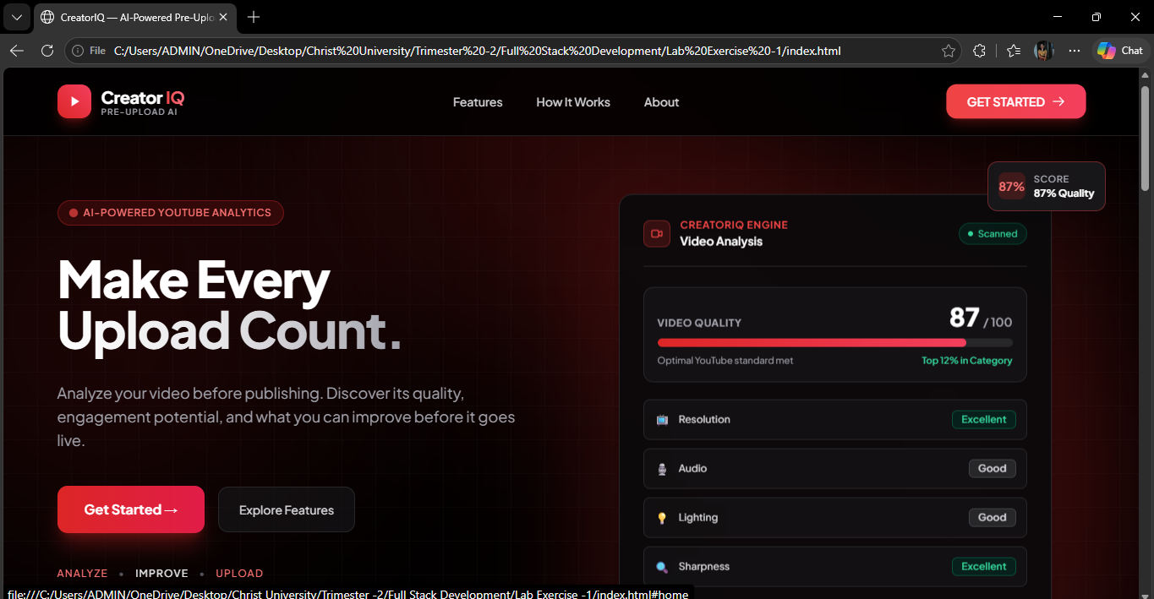

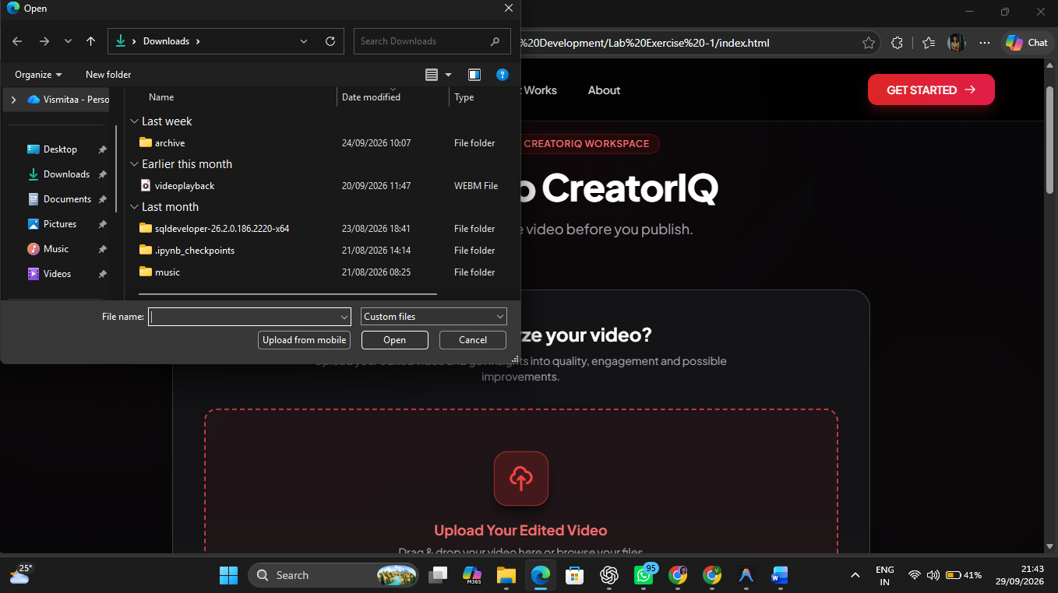

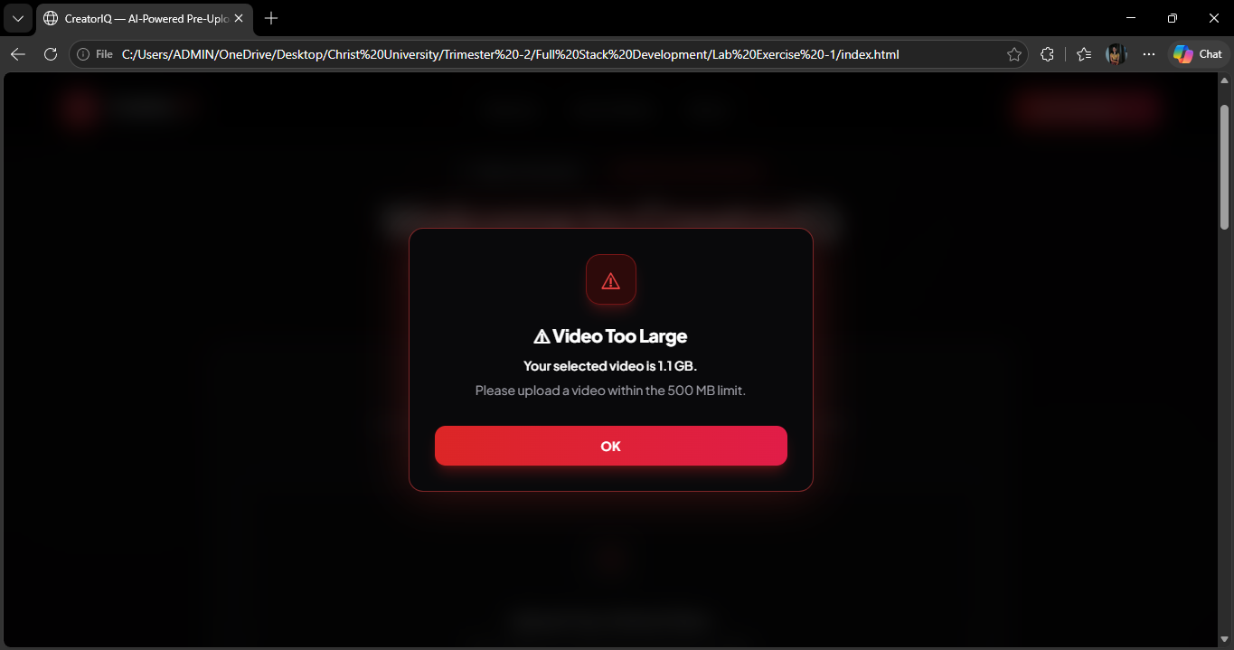
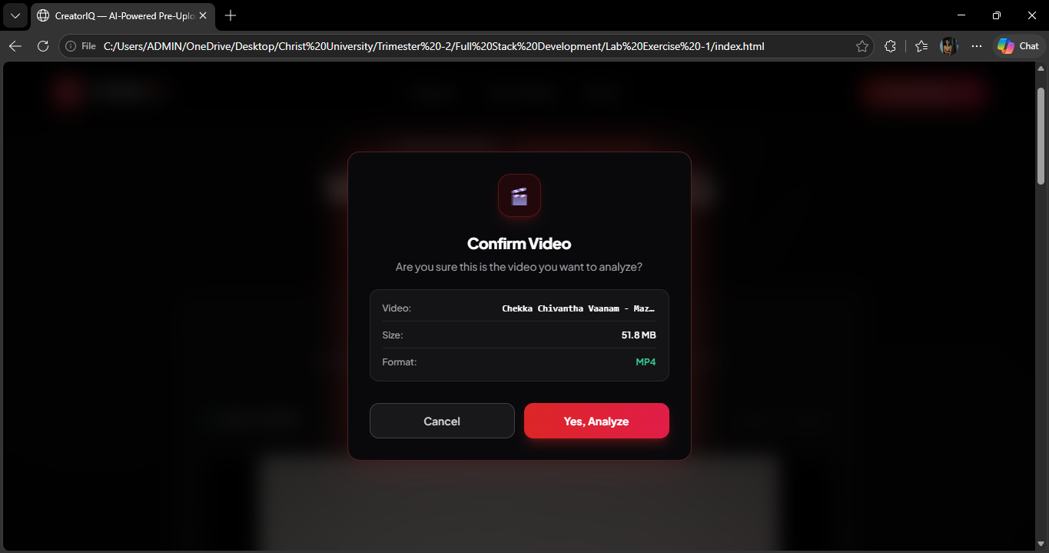
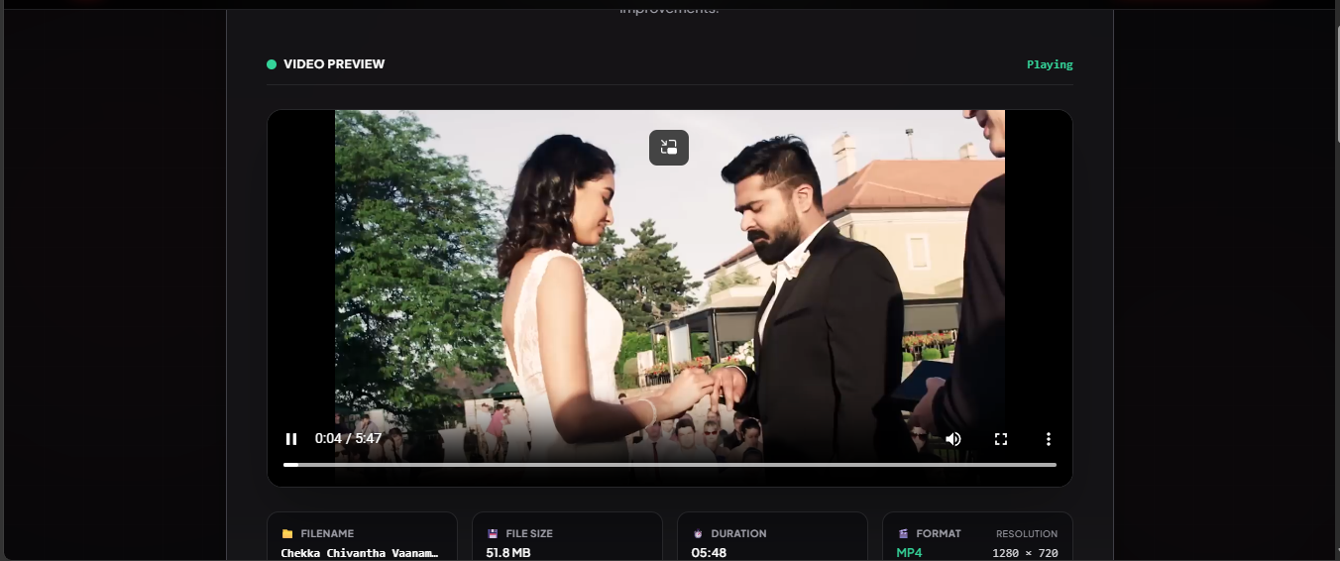
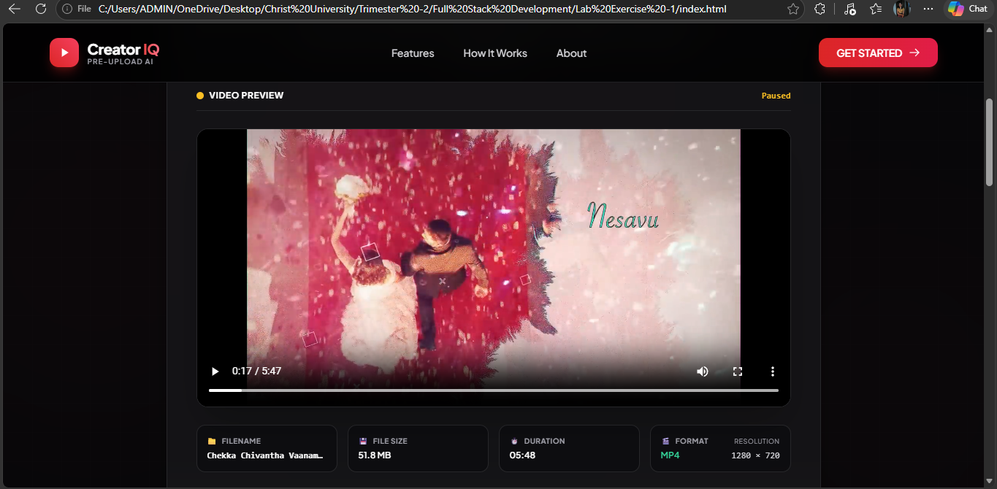
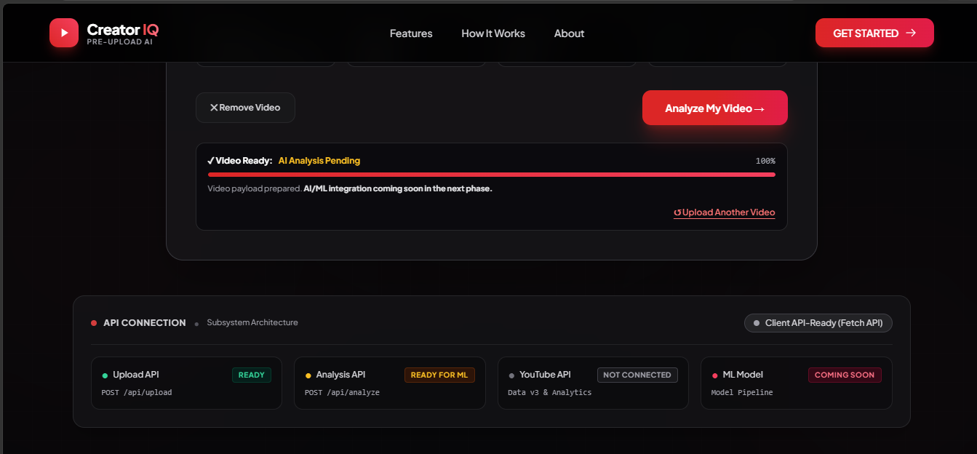
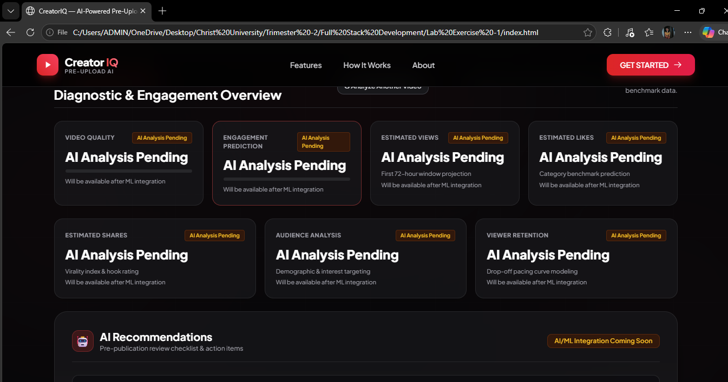
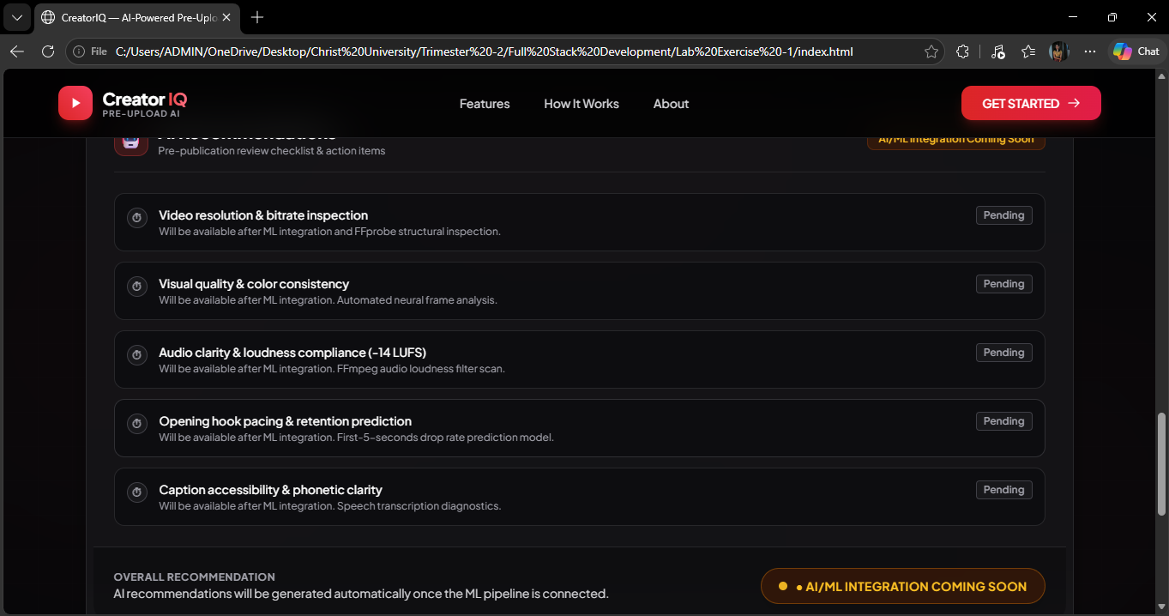

- AI Tool Used
ChatGPT
Purpose of AI Usage
Used ChatGPT to generate the frontend design ideas, HTML/Tailwind CSS structure, JavaScript event-handling logic, video upload validation, drag-and-drop functionality, page transition, and custom popup/modal interactions for the CreatorIQ YouTube video analyzer.
Prompt Used
Create and modify a responsive web application called CreatorIQ – AI-Powered YouTube Video Analyzer. Keep a premium dark/black theme with red YouTube-inspired accents, glowing gradients, floating UI elements, and a modern AI/SaaS appearance.
Implement event handling for the application, including:
- A Get Started button that uses a smooth animated transition to move from the landing page to the upload/home page.
- Video selection using the change event.
- Drag-and-drop video uploading using dragenter, dragover, dragleave, and drop events.
- Validation for supported video formats such as MP4, MOV, and WebM.
- A maximum video size of 500 MB.
- If the video exceeds the size limit, display a custom error popup stating that the video must be within the allowed limit.
- If the video is valid, display a custom confirmation popup asking: “Are you sure this is the video you want to analyze?”
- Display the selected video's filename, size, format, duration, and preview.
- Use the loadedmetadata event to obtain video duration and resolution.
- Provide Cancel, Remove Video, and Yes, Analyze interactions using click events.
- When Yes, Analyze is clicked, show a loading state and prepare the interface for future AI/ML analysis.
- Use custom Tailwind CSS modals instead of browser alert() or confirm().
- Keep the application responsive for desktop, tablet, and mobile.
Do not implement the actual AI/ML prediction yet. Keep the application API-ready so that future functionality such as video quality analysis, views/likes/shares prediction, engagement prediction, and AI recommendations can be connected later.
Use HTML, Tailwind CSS, and JavaScript, with clean and modular event-handling functions.
- GIT HUB URL

